Squirrels Homework – 30.04.2021
English
Next week, we will be starting a new book called the ‘Bad Tempered Ladybird.’ Please watch the video below to listen to the story:
https://www.youtube.com/watch?v=eL2Kz5osbFs

Now have a look at the minibeasts below. Talk to your adult about what makes them unique. Then complete the work under ‘Year 1’ or ‘Year 2.’

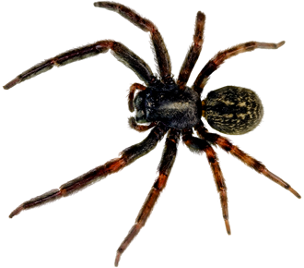
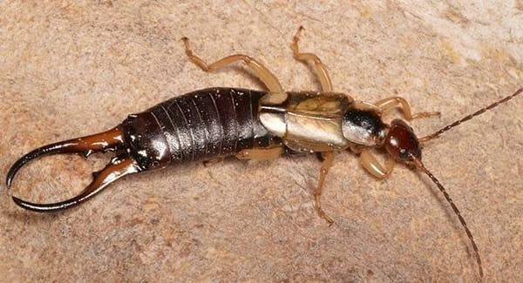
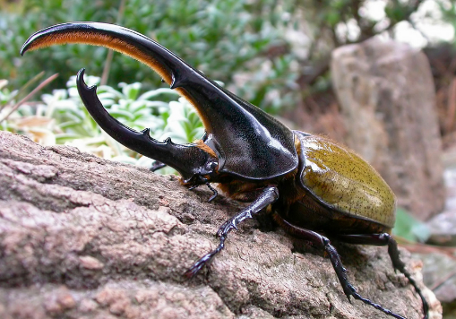

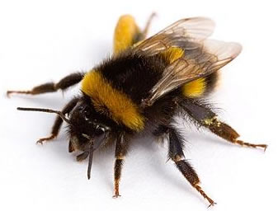
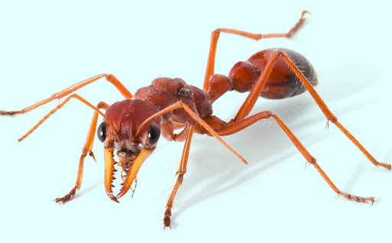
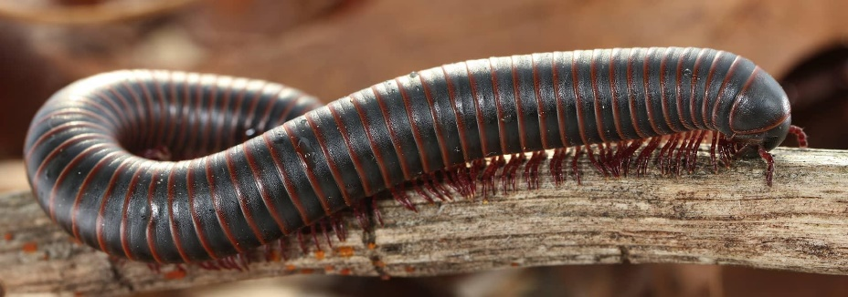
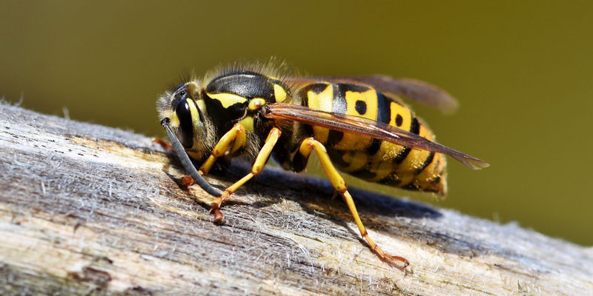

Year 1:
Choose 3 minibeasts from above and have a go at writing a sentence about what makes each one unique.
E.g. ‘Bees have black and yellow stripes and have a stinger.’

Year 2:
Choose 6 minibeasts from above and have a go at writing a sentence about what makes each one unique. Can you add an adjective?
E.g. ‘Buzzy bees have black and yellow stripes and have a stinger.’

Maths:
This week in maths, the children have been leaning about counting in 2s, 5s and 10s. Please choose either (Fluency) or (Challenging) and complete the work shown.

1. Please count in 2s, 5s and 10s to find out how many objects there are:
a) Count in 2s:
= __________

b) Count in 5s:
= __________
c) Count in 10s:
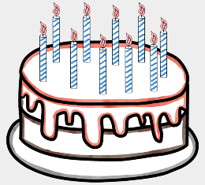
= __________

2. Please count in 2s, 5s and 10s to find out the missing numbers:

a) Count in 2s:
2, 4, ____, 8, 10 ____, _____, 16, 18, _____

b) Count in 5s:
5, _____, 15, 20, 25, _____, ______ 40, 45, _______

c) Count in 10s:
10, 20, 30, 40, _____, ______, 70, ______, 90, _______

Challenge:
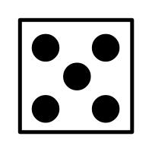
Circle the person that has has the greatest number of objects.
Tom

Sammy

Bob

Each is worth ten.

