W1 Maths Homework

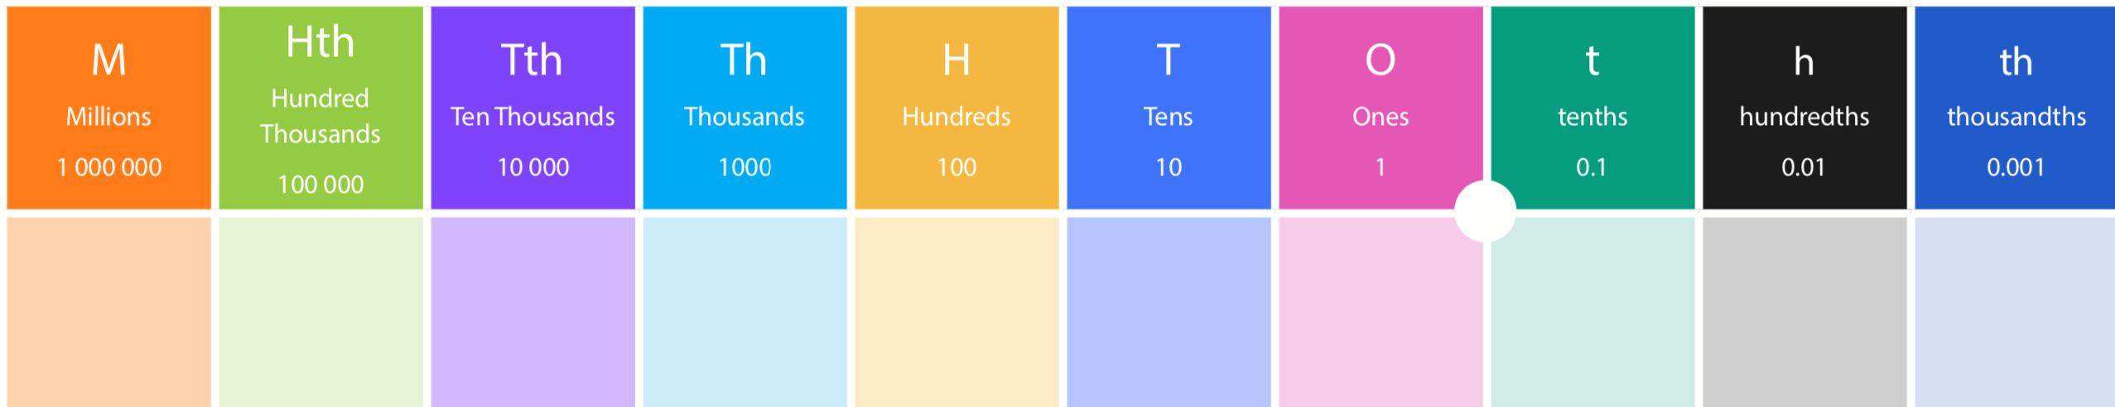

Warm up

1 whole = ?/1000
3 wholes = ?/100
4 wholes = ?/10

Write your answers as decimals too. Use the place value headings to make sure you are using 0 correctly. Remember, you do not need a 0 as the last digit in a decimal number. Then choose A, B or C depending on how confident you feel.

A
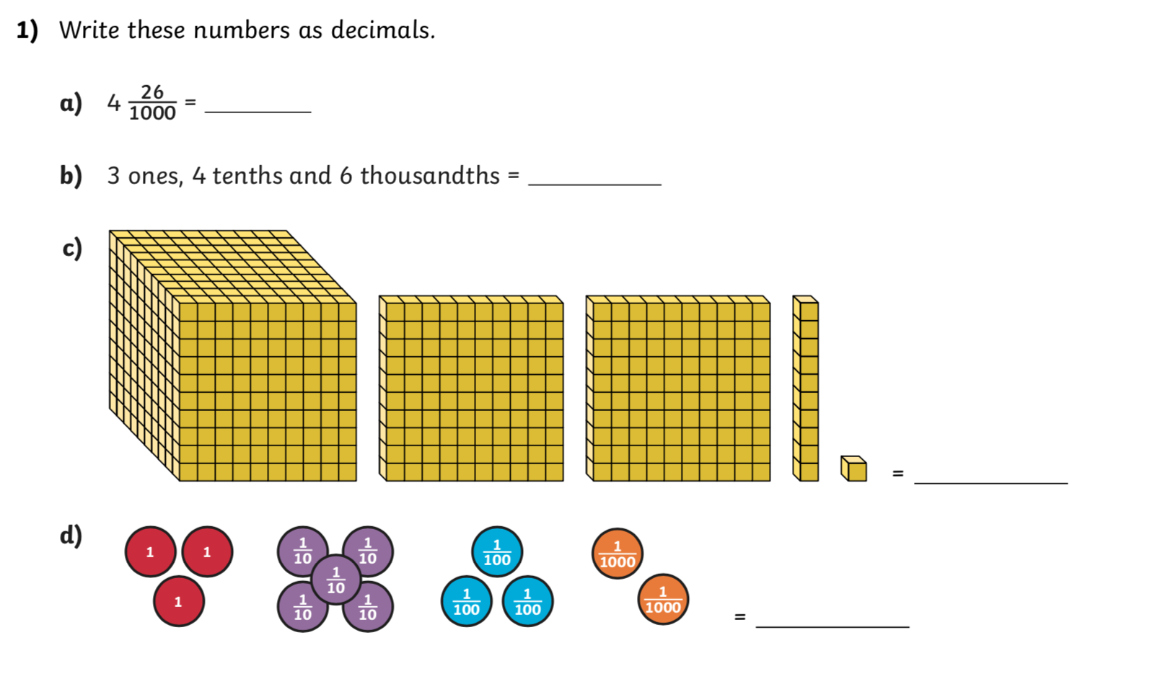

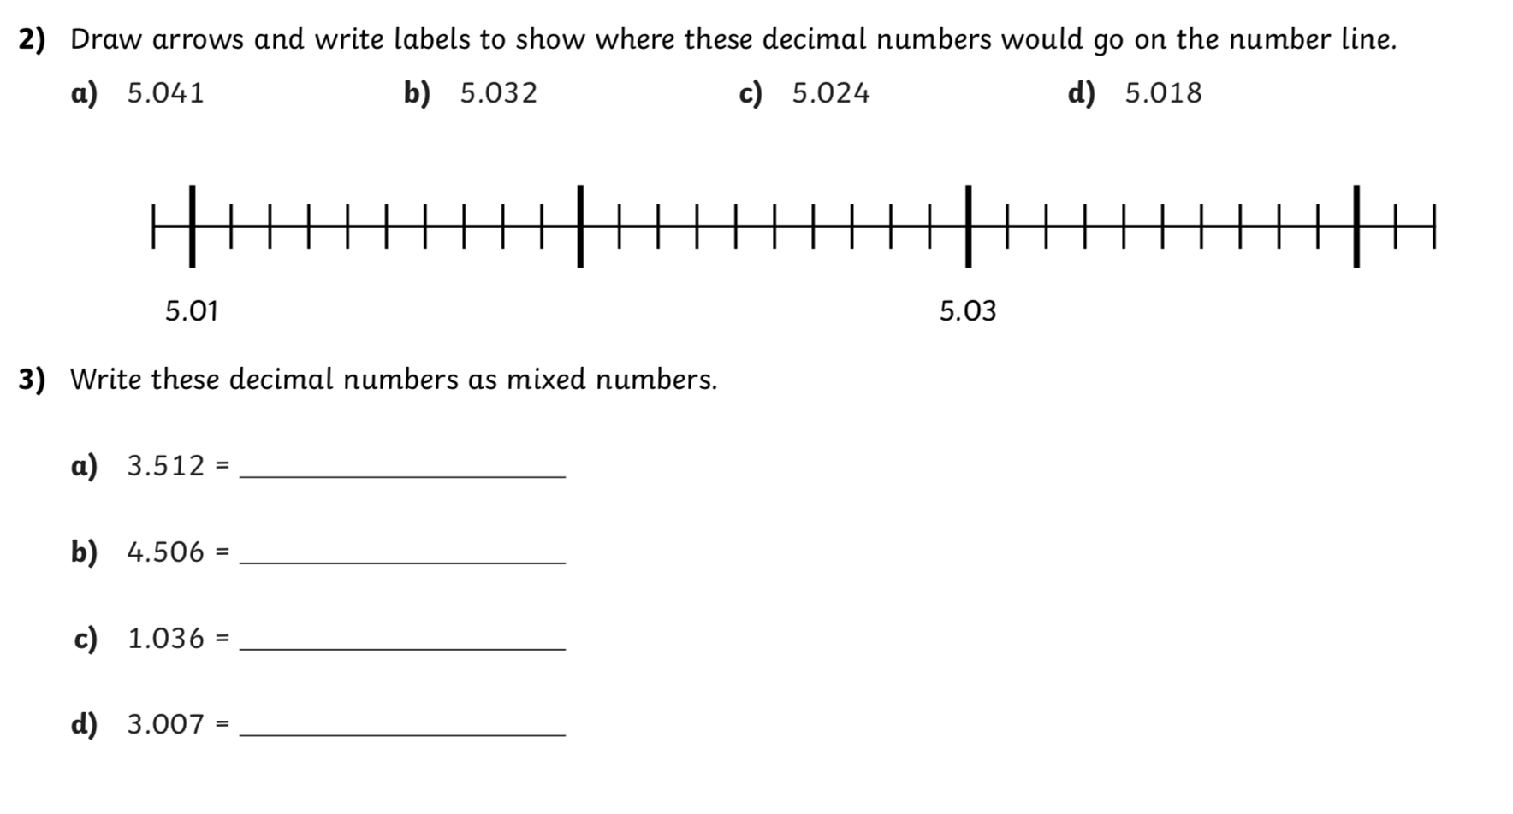
B

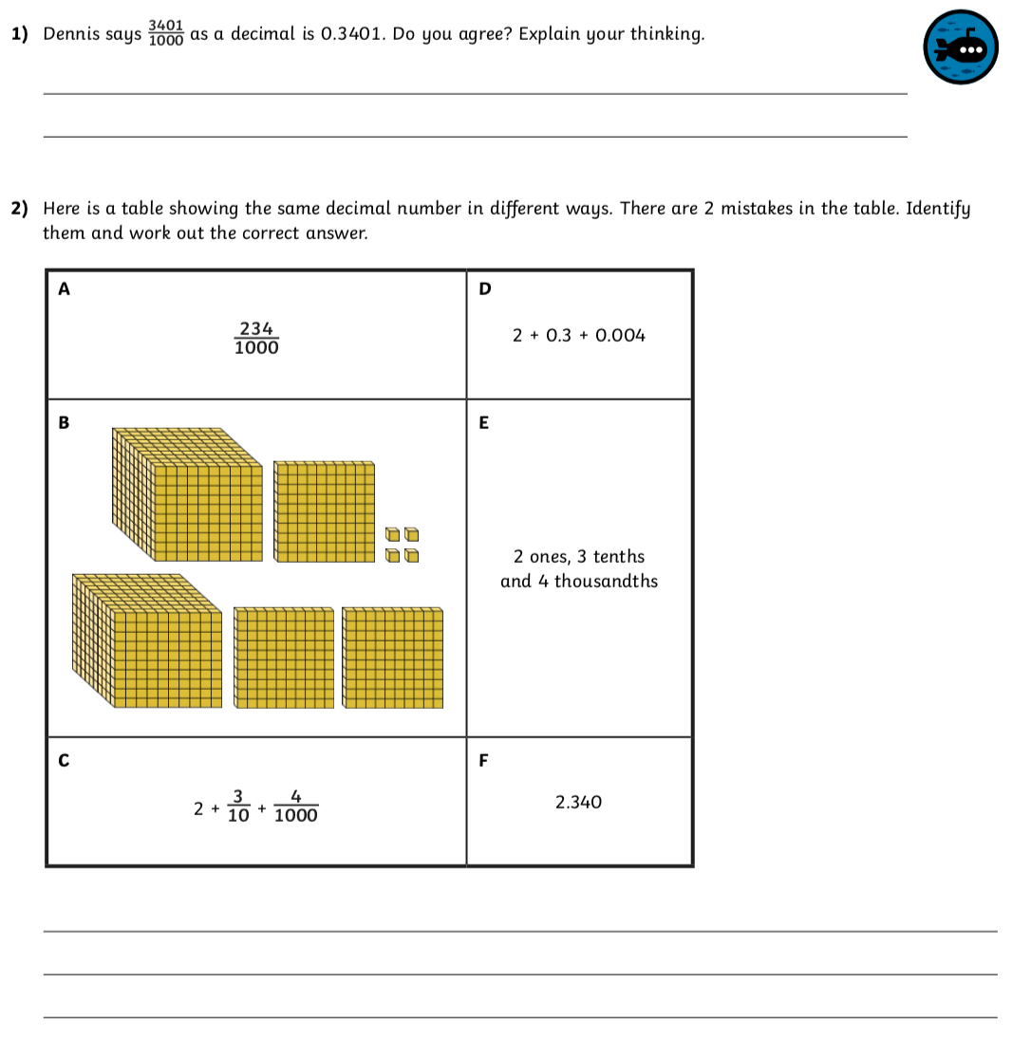

C

