Homework due Wednesday 28th April 2021

was
what
do
get
if
you
there
me
just
help

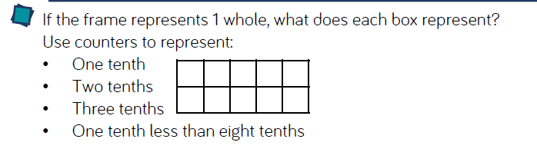
Maths – Fractions

