Spellings – (Mrs Siddiqui’s group)
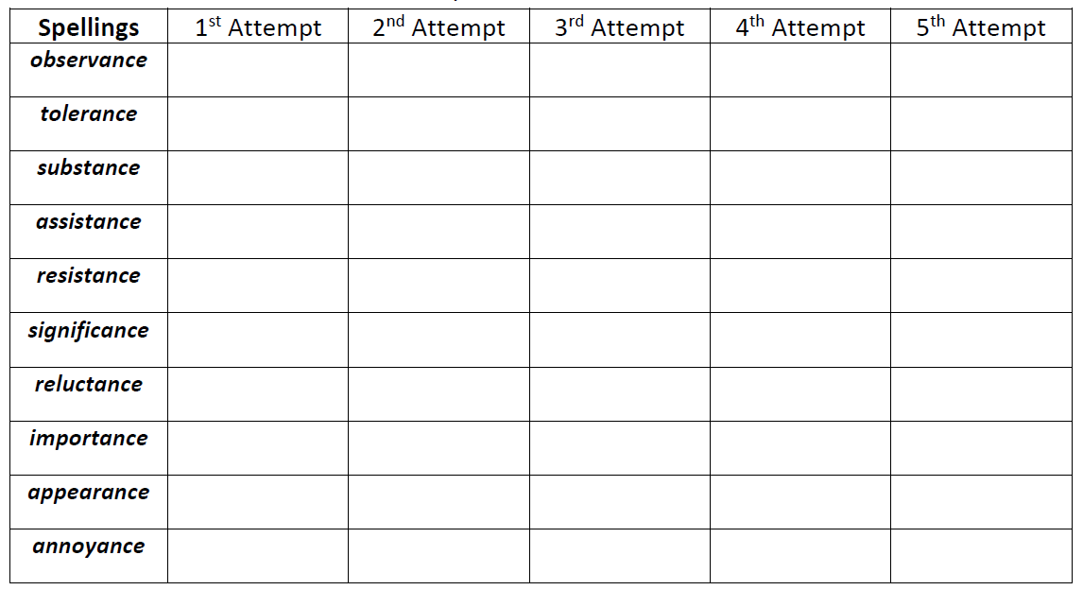

Mrs Bird’s Group
 | 1st Attempt | 2nd Attempt | 3rd Attempt | 4th Attempt | 5th Attempt
famous
enormous
various
curious
tremendous
infectious
nervous
conscious
suspicious

