Spellings – (Mrs Siddiqui’s group)
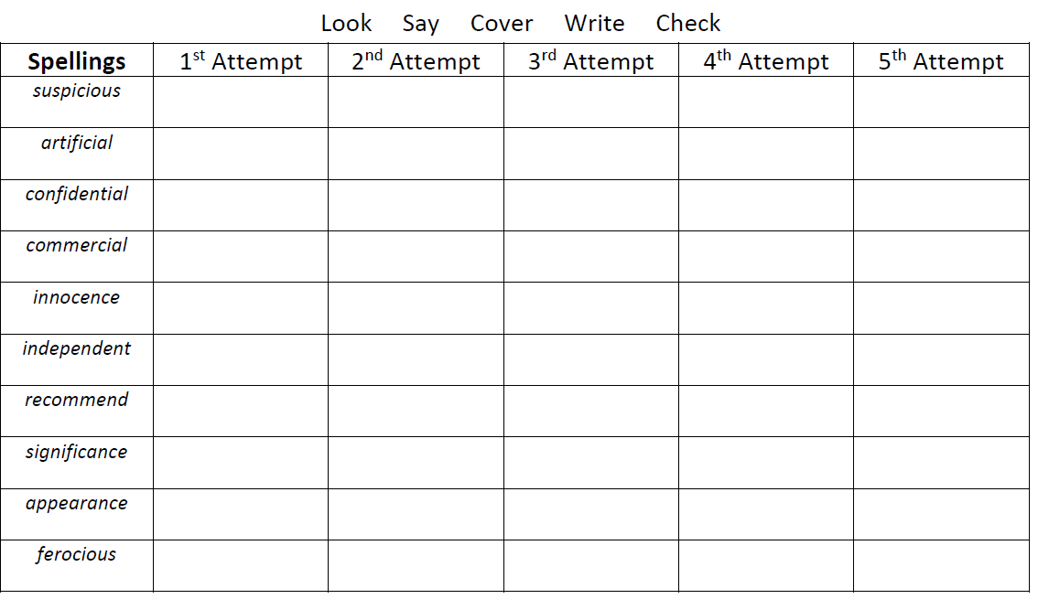

Mrs Bird’s Group
 | 1st Attempt | 2nd Attempt | 3rd Attempt | 4th Attempt | 5th Attempt
rhythm
symbol
system
mystery
mysterious
sympathy
syrup
physical
rhyme

