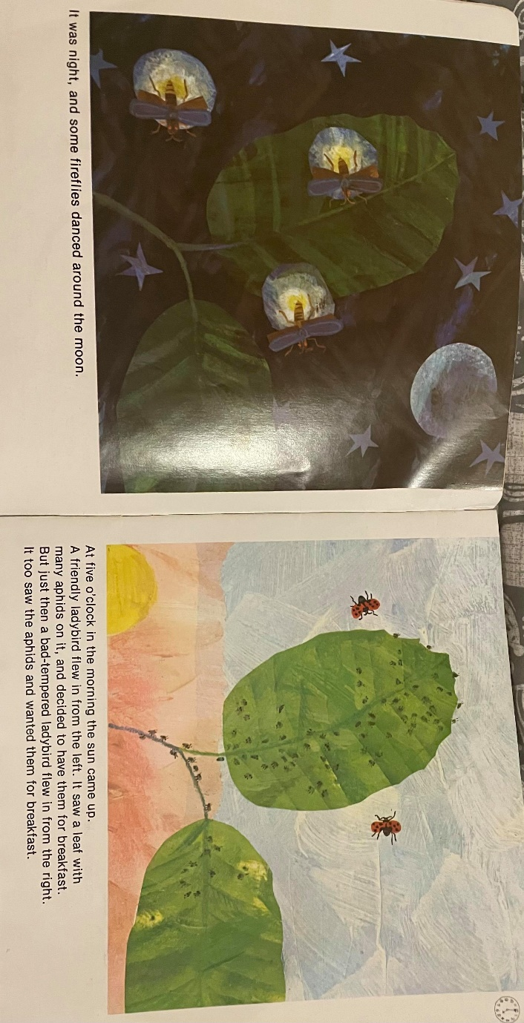
Squirrels Homework – 07.05.2021
English:
Year 1 and 2
This week we have been planning our own short narrative using the structure of ‘The bad-tempered ladybird.’
Please read through the first two pages with your adult and have a go at answering the questions below. These can be answered in your book or on this paper.

Questions:
1. What is the bad-tempered insect that we are using for our story?
_______________________________________________________

2. On the first page, the fireflies are dancing around the moon. What animal would you like in your story?
_______________________________________________________

3. What do you want it to do in the moonlight? E.g. ‘It was night, and an owl flew across the moon.’
______________________________________________________________________________________________________________

On the second page, what insect would you like to land on the leaves?
_______________________________________________________

Challenge:
How does the insect land on the leaves? Can you use an adjective?
______________________________________________________________________________________________________________

Maths:
This week we have been learning about number bonds up to 10 and 20. Please complete the questions below:
Year 1:
1. Please write the addition number sentences for each question. Remember you can swap the numbers!
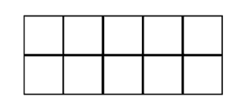
a)
_____________ + _____________ = _______

_____________ + _____________ = _______

_____________ + _____________ = _______

_____________ + _____________ = _______
b)

2. Can you fill in the missing numbers?
a) ______ + 5 = 10

b) ______ + 7 = 10

c) 10 + _______ = 10

d) 4 + 6 = ________

3. Can you complete the part-part whole models below?
a) b)
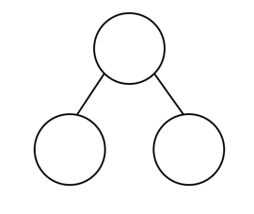
10
8
10

1

Challenge:
Have a go at writing your number bonds to 10.
To help you, you could find yourself 10 objects and have a go at separating them into parts.

Year 2:
1. Please write out the addition number sentence that matches the ten frames.
Challenge: Can you write the fact families for each one as well?
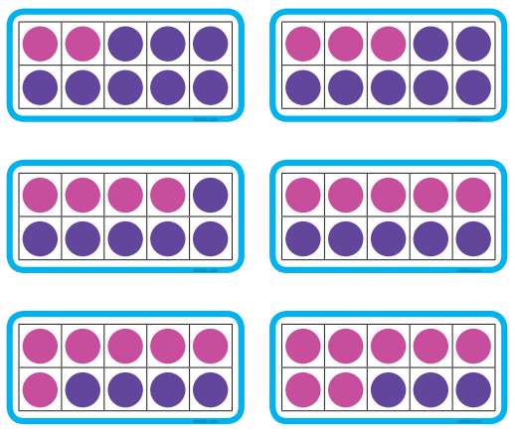
a)
___________+ ___________ = _______

___________ + ___________ = _______

___________+ ___________ = _______

___________ + ___________ = _______
b)

___________+ ___________ = _______

___________ + ___________ = _______
c)

2. Can you fill in the missing numbers?
a) ______ + 5 = 20

b) ______ + 7 = 20

c) 10 + _______ = 20

d) 4 + 16 = ________

3.
a) b)
20
13
20
2

Challenge:
Please have a go at the mastery card below.
