Squirrels Homework – 14.05.2021

English:
Year 1 and 2:
Please listen to the story of the ‘bad tempered ladybird.’ Have a think about what feelings the bad tempered ladybird goes through in the beginning, middle and end.
https://www.youtube.com/watch?v=CFMaEVfntnM

Feelings:
End:
Middle:
Beginning:

Next, have a go at answering these questions about the story in your books:

1. Do you like the ‘bad tempered ladybird’ at the beginning of the story?

2. What is the biggest animal that the bad-tempered ladybird meets?

3. What does the hyena show the ladybird to scare him?

4. What does the bad-tempered ladybird always say when the animal shows what makes them dangerous?
“You’re not ____________________________________________________”

5. What does the friendly ladybird do at the end of the story?

Maths:
This week both year 1 and 2 have been learning about adding by counting on and subtracting by counting back. Please complete the questions below that have been split into and

Please use the number-line to work out these answers. Make sure you check if it is addition or subtraction!

1.
a) 14 + 5 =  b) 17 – 8 =  c) 12 + 6 = | d) 20 – 10 =  e) 8 + 5 =  f) 14 – 8 =

2. Please add counters to the ten frames to work out the addition number sentences. One of the numbers has been put in the ten frame already.
a) 12 + 7 =

b) 15 + 3 =

3. Please cross off the counters to find the answers to these subtraction questions:
a) 18 – 6 =

b) 15 – 7 =

Please use the hundred square to work out these answers. Make sure you check if it is addition or subtraction!
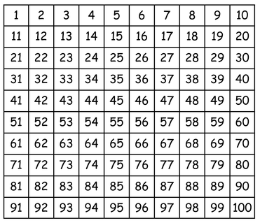

1.
a) 62 + 7 =  b) 31 – 9 =  c) 22 + 8 = | d) 100 - 20 =  e) 45 + 6 =  f) 74 – 12 =

2. Please add by making ten. There is an example to show you how to do it:
Example:

a)
b)

d)
c)

Challenge:
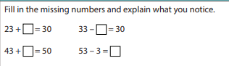
a)

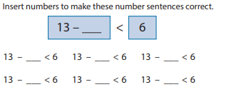
b)

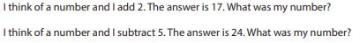
c)

