Squirrels Home Work – 21.05.2021
English:
We have come to the end of writing our short narratives based on ‘The bad-tempered ladybird.’ Today you are going to be explorers! Please go into your garden, local park or woods and see how many different minibeasts you can find.
Activity:
Please pick your favourite minibeast that you found and have a go at drawing a picture of it and then write a description of it.
Think about:
- What does it look like?
- Where did you find it?
- What was it doing?

Year 1 – Please use adjectives in your sentences.
Year 2 – Please use expanded noun phrases in your sentences.

Challenge:
Once you have written your description, use your Ipad/tablet or a phone to do some research to find out some fun facts about your minibeast.

Example:
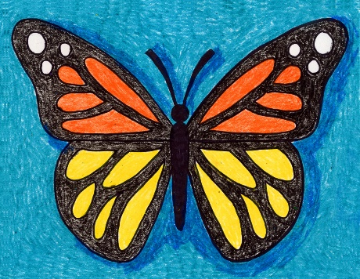

This butterfly has soft, colourful wings. It has 6 thin legs and 2 black antennae. I found on one of the leaves in the garden. It was drinking water from the crystal clear dew drops that were sitting on the leaf. It suddenly flew gracefully through the air in search of some more water.
Some fun facts about butterflies are that the biggest butterfly is called a ‘Queen Alexandra’ which has wings of 26cm. Another fun fact is that butterflies cannot fly when they are cold.

Maths:
This week the children have been learning about addition and subtraction. Please find your year group to answer the questions.

Year 1: Subtraction crossing ten.
(If you are unable to print this work, please just write the answers to the questions in the home work books)

1. Have a look at the part-part-whole models below and work out the missing part. Try and find some objects in your house to help you.
Remember: The best way to answer it is to subtract the part number from the whole number.

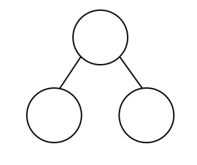
17

________ - _________ = ________
8

________ - _________ = ________
6

15

2. Please complete the bar models.
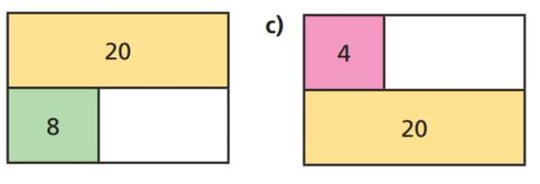
Remember: If you need to find a part, subtract the other part from the whole number.
b)

a)

3. Have a go at filling in the missing numbers.

a) 7 + ______ = 16

b) 12 + _____ = 19

c) 4 + ______ = 18

d) 6 + ______ = 21

Year 2: Adding and subtracting tens/Adding a 2-digit number and a 1-digit number/ Subtracting a 1-digit number from a 2-digit number.
(If you are unable to print this work, please just write the answers to the questions in the home work books)

1. Please have a look at the questions below. Use the dienes to help you add tens.
a)
=

+

b)
=

+

2. Use the number-line to answer these questions.
- 18 + 7 =
- 14 + 5 =
- 9 + 12 =
- 6 + 15 =

3. Please look at the questions below and add the numbers together using the dienes to help you.
Remember: You may need to make some of the ones into a ten.

a) 25 + 7
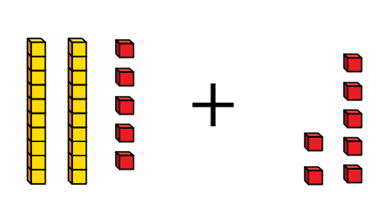
=

b) 59 + 5 =
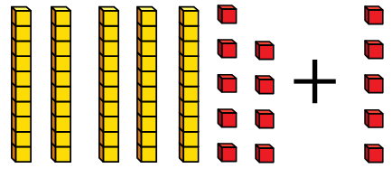
=

4. Please have a look at the subtraction questions below.
Remember: You need to exchange one of the tens.
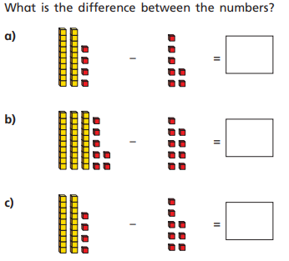

Challenge:
a)

b)

