Badgers Homework – Week 5
A
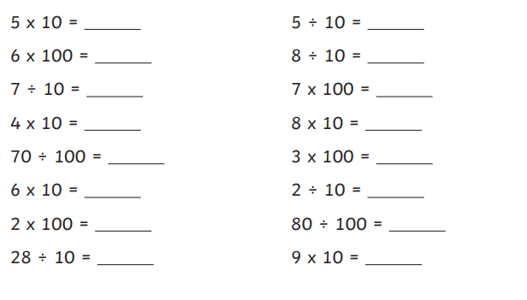
B
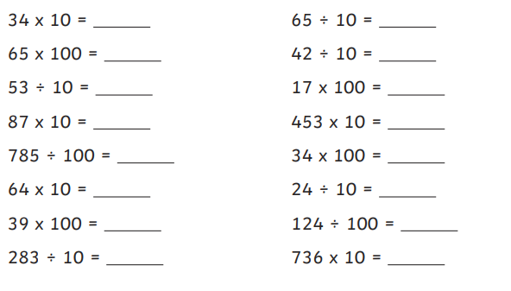

C
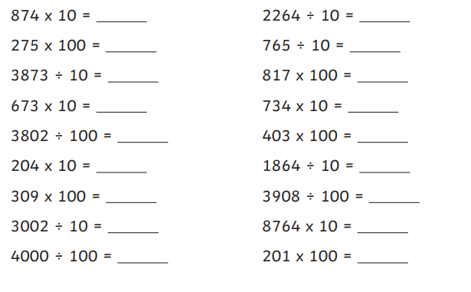

Challenge: Complete the table below.
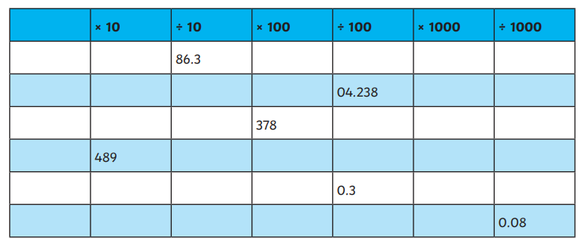

ENGLISH
Play a game with another member of your house. You choose a 2 or 3 syllable word and your opponent has to begin their word with the last syllable of the previous word. For example:
Dinosaur – soaring – ingenious – ousted – tedious
Fragment – mentor – torrent - rented
See how long a chain you can make.
Research William Blake and write the five most interesting facts in your book.

