Week 3 Badgers Homework
Maths
Complete the dice game and only 1 section – A, B OR C
Can you throw two dice, put them next to each other then shout the number that will make the total 100? For example if you throw a 1 and an 8 you would shout 82.
How many can you get right in a minute – get an adult to count and time you! Dojo for the highest score!
A
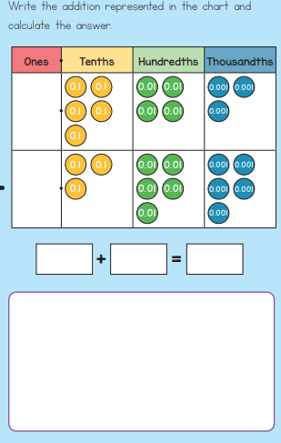
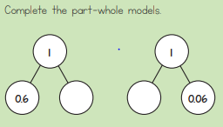

Order the following from smallest to
largest:
0.2, 0.23, 0.203, 0.1, 0.023

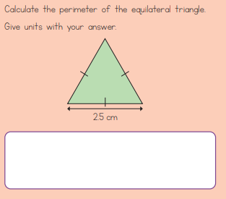
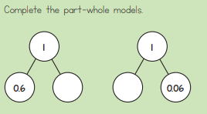
B

Order the following decimals, smallest to
largest:
0.065, 0.605, 0.066, 0.706, 0.067
Complete the following calculations.
0.4 + 0.7 =
0.2 + 0.9 =
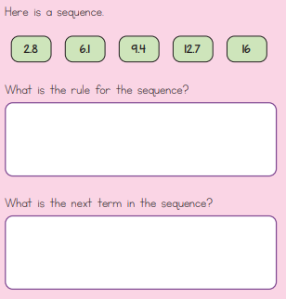
C
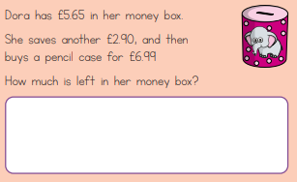

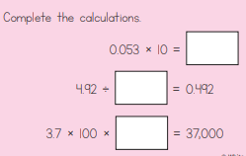

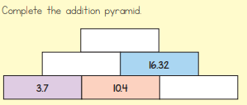

Spellings
Remember to learn your spellings for next week. They are all on Purple Mash.
English
Write an interesting paragraph to describe the picture below. Who is the man? What is he doing? Where is he? Describe his surroundings.

