HOMEWORK Week 2

Maths – Only choose one section from A, B OR C.

A

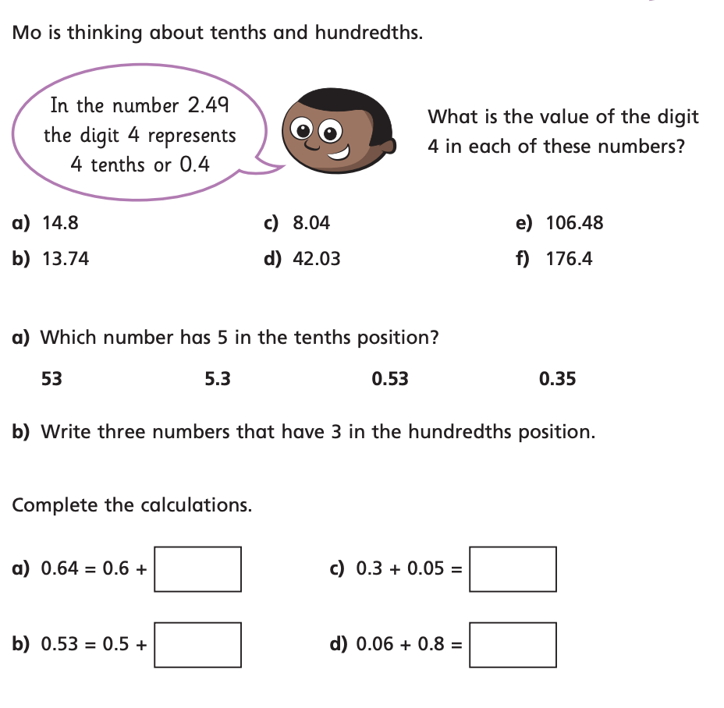

Match the numbers to the place value grid

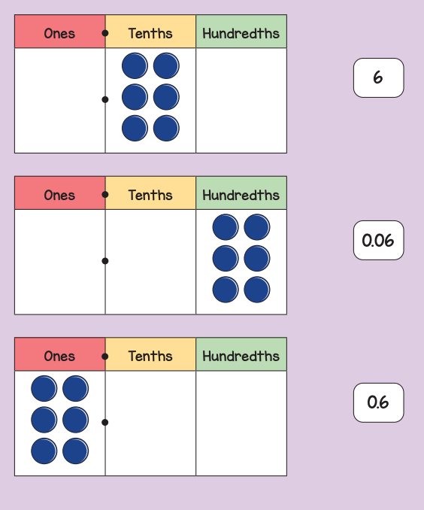

B

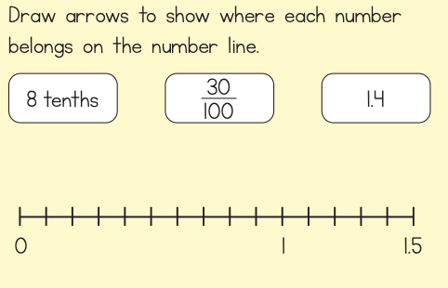

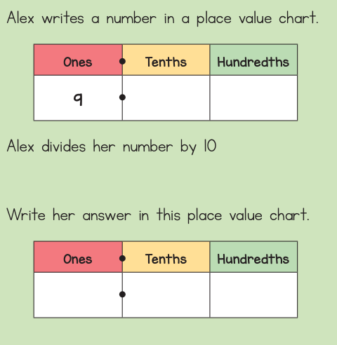

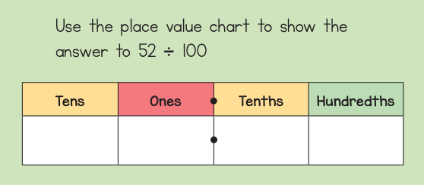

C - Challenges

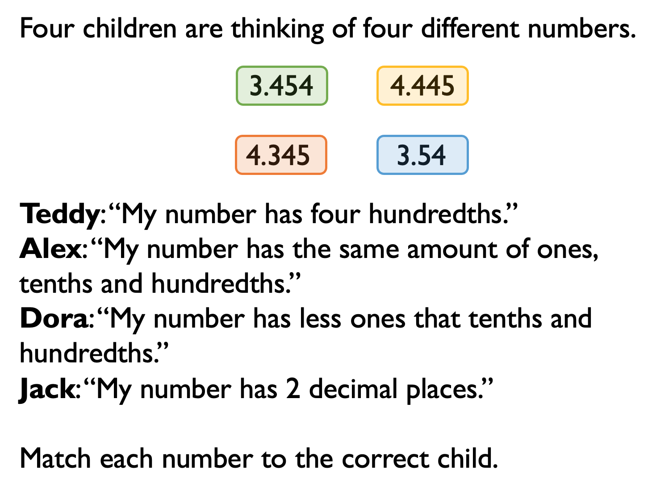

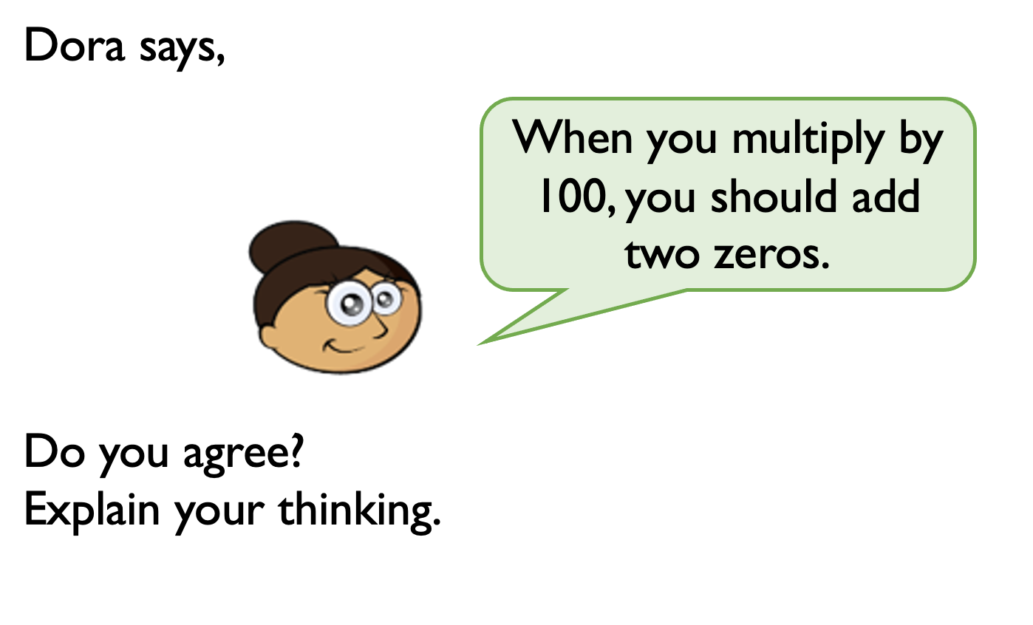

English Homework

Research and draw your own lifecycle of a mammal. Include five fun facts about your animal.

Ext – Research what St Elmo’s Fire is and why it helped Darwin see the Porpoises.

PE

Can you run for 10 minutes or a whole Km? Measure your distance or time yourself. We can compare how we all got along!

