Week 4 - Badgers Homework

Maths

Please complete either section A, B, OR C.
Complete the pyramids by adding the two numbers that are next to each other and filling in the box above until you reach the top.

A

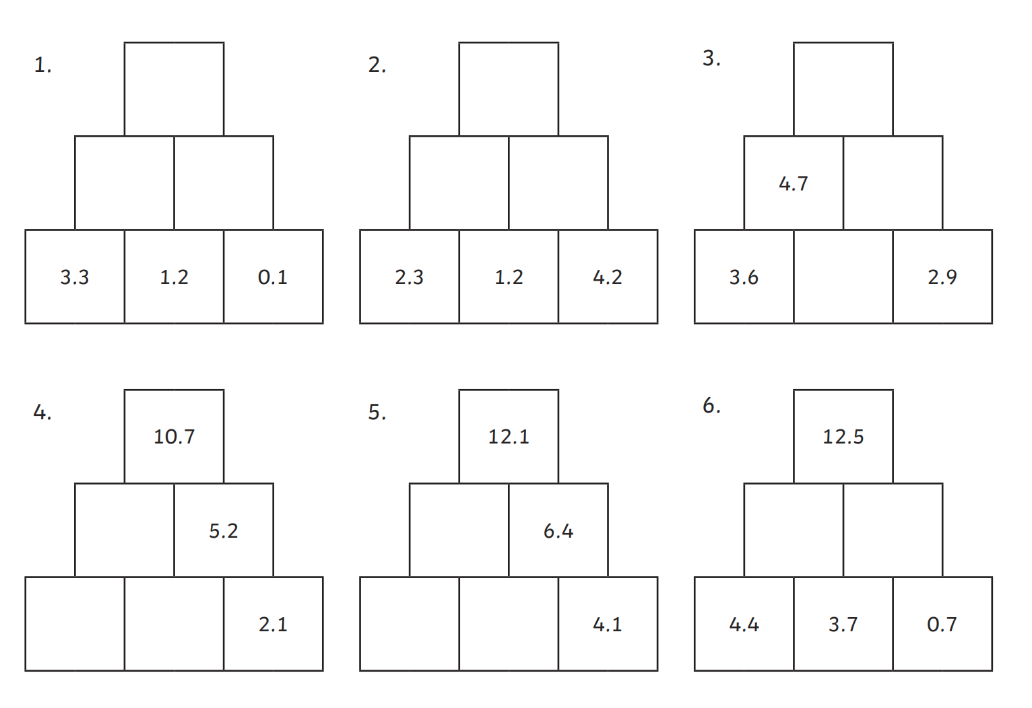

B

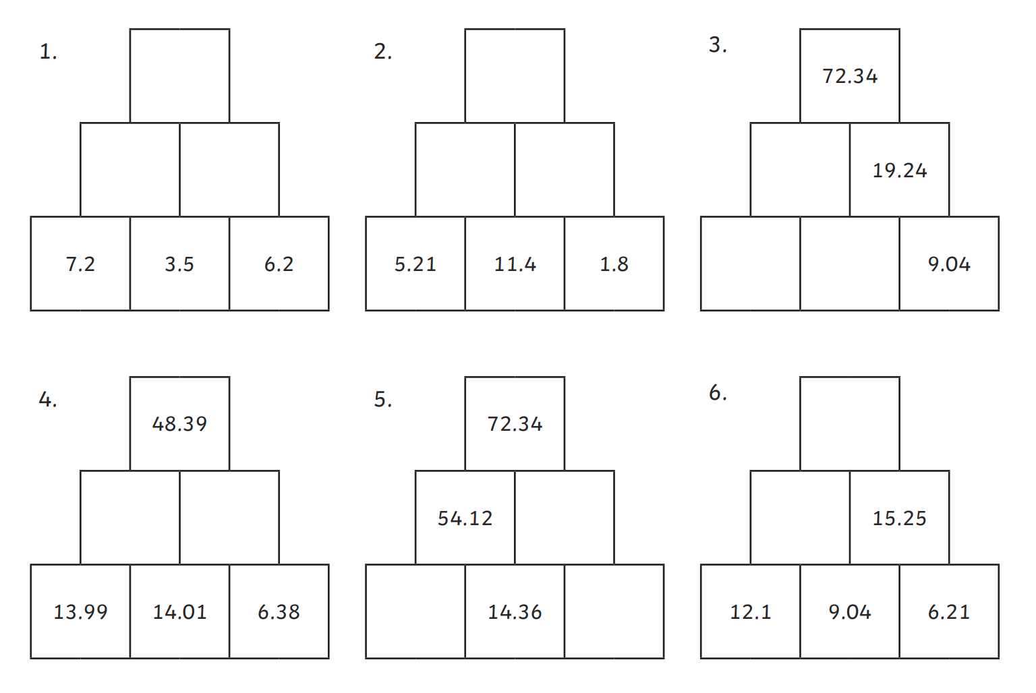

C

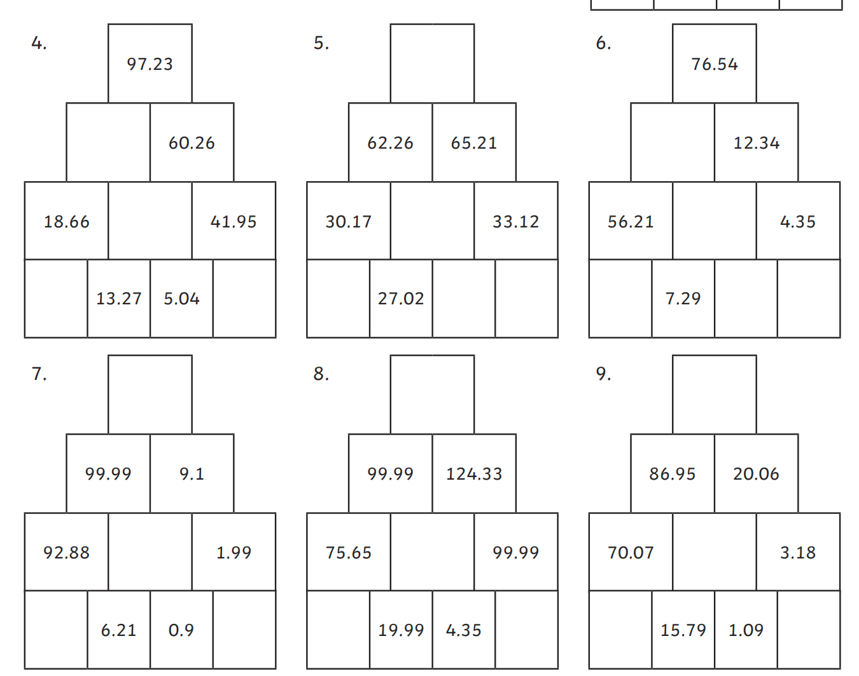

Spellings

Remember these are on PurpleMash!

English

Complete the attached comprehension then take a few moments and see if you can spot any of the birds in your garden.

