Homework 18.6

Can you work these out mentally? You don’t need to do all of them. Think carefully about whether the hundreds, tens or ones column will change.
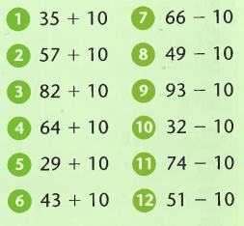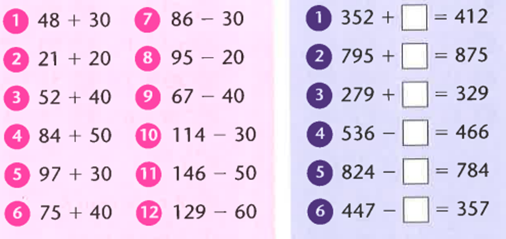

Only use the 100 square if you get really stuck.
