Spelling Miss Axons group 11.6
- That
- There
- Could
- Would
- School
- House
- When
- Where

Maths

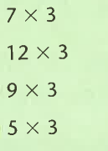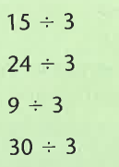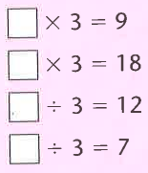

Try not to use the multiplication grid below unless you get really stuck!

