Spellings – (Mrs Siddiqui’s group)
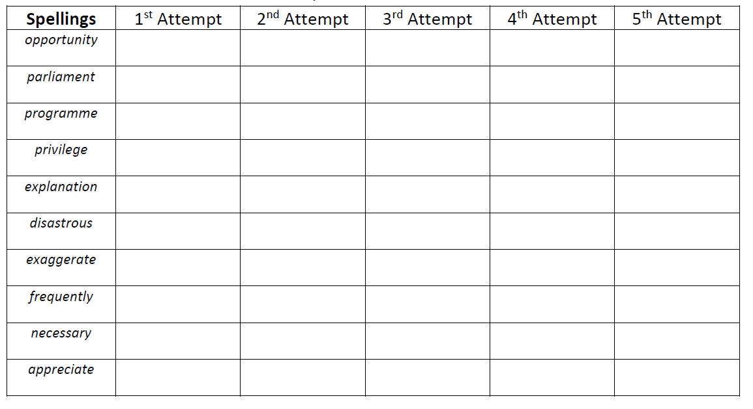

Mrs Bird’s Group
 | 1st Attempt | 2nd Attempt | 3rd Attempt | 4th Attempt | 5th Attempt
measure
treasure
pleasure
enclosure
creature
furniture
picture
adventure
nature
future

