Squirrels Homework – 18.06.2021
English
Year 1 and 2:
Please look at the pictures below. You can choose either Ossiri, The Bala Mengro or both of them. I would like you to write as many adjectives around them as possible and then write some sentences using those adjectives.

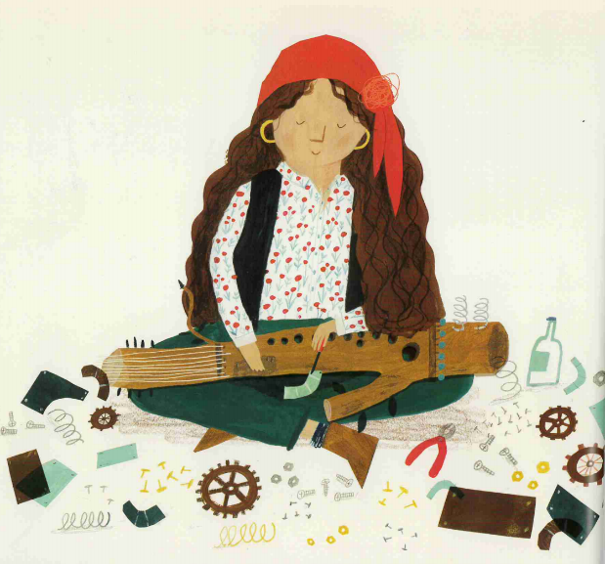
Ossiri The Bala Mengro
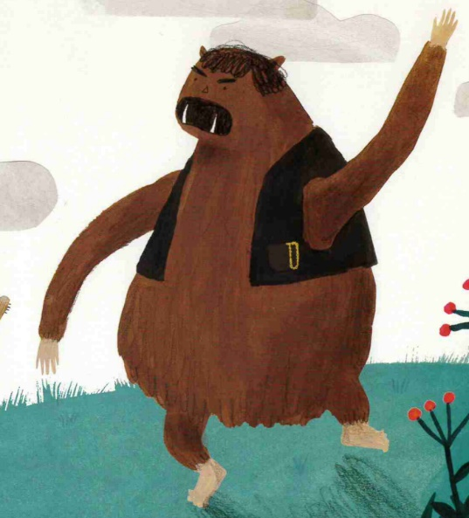

Example:
Large, bushy eyebrows.
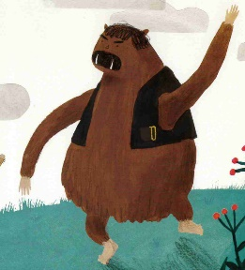
Sharp, glinting fangs.

Long, scruffy, brown fur.
Short, black waistcoat.

The Bala Mengro has large, bushy eye-brows. He has large, white and glinting fangs that stick out of the bottom of his mouth. He is wearing a small, black waistcoat which has a gold buckle on it. Finally, he is covered in long, scruffy brown fur.

Maths
Year 1:

1. Can you circle the Squirrels below in groups of 3?

2. Can you share these counters?
a) Please share these counters between 4 groups.

There are _________ counters altogether.
There are _________ groups.
There are _________ in each group.

b) Please share these counters between 5 groups.

There are _________ counters altogether.
There are _________ groups.
There are _________ in each group.
3. Please write if these groups are equal or unequal.
There are _________ counters altogether.
There are _________ groups.
There are _________ in each group.
There are _________ counters altogether.
There are _________ groups.
There are _________ in each group.

a)
There are _________ counters altogether.
There are _________ groups.
There are _________ in each group.
There are _________ counters altogether.
There are _________ groups.
There are _________ in each group.

There are _________ counters altogether.
There are _________ groups.
There are _________ in each group.
There are _________ counters altogether.
There are _________ groups.
There are _________ in each group.

b)
There are _________ counters altogether.
There are _________ groups.
There are _________ in each group.
There are _________ counters altogether.
There are _________ groups.
There are _________ in each group.

There are _________ counters altogether.
There are _________ groups.
There are _________ in each group.
There are _________ counters altogether.
There are _________ groups.
There are _________ in each group.

4. Make these groups equal.
There are _________ counters altogether.
There are _________ groups.
There are _________ in each group.
There are _________ counters altogether.
There are _________ groups.
There are _________ in each group.

There are _________ counters altogether.
There are _________ groups.
There are _________ in each group.
There are _________ counters altogether.
There are _________ groups.
There are _________ in each group.

a)

There are _________ counters altogether.
There are _________ groups.
There are _________ in each group.
There are _________ counters altogether.
There are _________ groups.
There are _________ in each group.

There are _________ counters altogether.
There are _________ groups.
There are _________ in each group.
There are _________ counters altogether.
There are _________ groups.
There are _________ in each group.

There are _________ counters altogether.
There are _________ groups.
There are _________ in each group.
There are _________ counters altogether.
There are _________ groups.
There are _________ in each group.

b)

Year 2:
1. Multiplication from Pictures
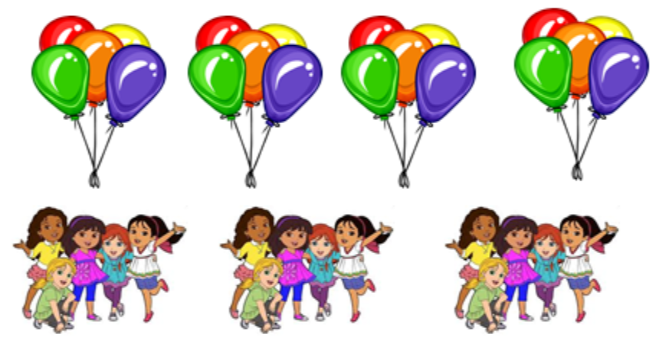
a)

There are _________ groups of _________.

_______ + _______ + _______ + ________ =

_______ x _______ =

b)

There are _________ groups of _________.

_______ + _______ + _______ + ________ =

_______ x _______ =

2. Arrays
a)

b)

3. Can you share these counters?
a) Please share these counters between 4 groups.

There are _________ counters altogether.
There are _________ groups.
There are _________ in each group.
______ ÷ ________ =

b) Please share these counters between 5 groups.

There are _________ counters altogether.
There are _________ groups.
There are _________ in each group.
______ ÷ ________ =
Challenges:

