

**Science Intent**

Our vision

**Living and learning with faith, friendship and fun**

Charing School is an inclusive family, proud of our faith in God and our friendship with our community. We develop respect, aspiration, curiosity, tolerance and determination. We are a creative, compassionate and confident team.

Mission Statement

Our Christian values of love, hope, truth, friendship and kindness underpin everything we do at our school. We work together as a community, within Aquila the Canterbury Diocese Multi Academy Trust.

* We believe our school plays a significant part in a pupil’s childhood providing a safe and nurturing environment. A place a child can enjoy being an individual and develop as a well-nurtured human being.
* Our curriculum is broad and balanced. It builds on the knowledge, understanding and skills of all children, whatever their starting points. We want our children to experience a wider curriculum in abundance, ready to embrace the next chapter in their learning journey.
* The outdoor environment and the local community are considered an opportunity for active learning for all pupils. We will fully embrace the surrounding resources and utilize our vast outdoor space.
* We aim to educate our children for the present and also for the future: giving them an understanding of the world, everlasting experiences and life skills that they will take forward.
* We celebrate the diversity and cultural wealth of the wider community, specific to Charing.
* We will engage parents in supporting pupil’s achievement, behavior and safety and their spiritual, moral, social and cultural development.

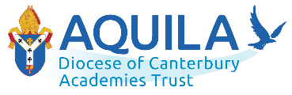

At Charing we believe that Science is a body of knowledge built up through experimental testing of ideas. The principal objectives of the teaching of science at Charing are to stimulate pupil’s curiosity in finding out why things happen and to develop interest and enjoyment in science. Our children learn to ask scientific questions that relate to the world they live in. They are encouraged to plan, implement, conclude and evaluate scientific investigations. The teaching of science at Charing enables pupils to communicate scientific ideas effectively through the use of relevant scientific language and develop children’s ideas and ways of working, that enable them to make sense of the world in which they live.

The Science curriculum followed at Charing is made up of 28 units of study, each clearly indicating progression in key scientific knowledge and concepts. Each of the 28 units of study indicate the aspects of knowledge to be developed as the children progress through Key Stage 1 and 2. As a school we use Kent Primary Science Scheme of Work to support our Science planning.

**Progression Narrative**

Pupils begin their science learning journey in Reception where guided exploratory play is key to developing enquiring minds. Working scientifically skills are embedded throughout the curriculum to enable our pupils to understand the value of science in context.

Science knowledge at Charing is built on through our primary school as topics are revisited throughout a child’s primary school life. Pupils learn about natural phenomena and the world around them. Some topics covered and revisited are: Animals including Humans, Living Things and their Habitats, Plants, Materials, Forces and Electricity. We follow the National Curriculum as a basis and the Kent Primary Science scheme of work.

Every year we will take part in a Science week which sparks children’s enthusiasm for the subject even further through workshops, assemblies and a range of science enquiries in lessons.

The Pathway we use at Charing helps meet the requirements of the intent, implementation and impact framework.

**Intent**. They help assure curriculum breadth, coverage, content and a structure that enables clear progression in knowledge and skills. (Ofsted Handbook, 157: “It is clear what end points the curriculum is building towards, and what pupils will need to be able to know and do at those end points … The school’s curriculum is planned and sequenced so that new knowledge and skills build on what has been taught before, and towards those defined end points.”)

**Implementation**. The teaching activities in the Kent Primary Science Scheme of Work will help assure lively, effective and appropriate learning based on the structured Pathways. At the start of each topic teachers take time to find out what our children already understand and want to find out. Through teacher modelling and planned questioning, we want our children to wonder about and be amazed and surprised by the world around them. Key scientific language is modelled throughout lessons enabling our children to be familiar with and use vocabulary accurately. Teachers are also encouraged to plan in trips and visitors to enhance our children’s learning experience. We aspire to promote children’s independence and for all children to take responsibility in their own learning.

**Impact**. The Kent Primary Science Scheme of work assessment frameworks will help demonstrate that teaching has resulted in clear and appropriate outcomes.

The science topics that need to be covered at Charing in Key Stage 1 and 2 can be seen below.

However, at Charing and in September 2021, these topics will not be able to be followed exactly in this order. This is because we currently have 4 classes in Key Stage 1 and Key Stage 2, not 6, so the topics need to be mapped out carefully for classes with mix year groups in. It is planned for topics missed in 2021-2022 due to mixed classes will be covered in 2022-23. Also, due to Covid-19 topics missed due to school closure have been factored into future planning. The topics covered by each year group and their progression can be seen in the ‘Class overview 2021-2022’ table below.

Topics and progression of scientific knowledge

|  |  |  |  |  |  |  |
| --- | --- | --- | --- | --- | --- | --- |
| **Topics** | **Year 1** | **Year 2** | **Year 3** | **Year 4** | **Year 5** | **Year 6** |
| **Plants** | **Identify and describe basic structure** | **Conditions for growth**  **Sequence of growth** | **Conditions for growth**  **Functions of parts**  **Life cycle** |  |  |  |
| **Living things and habitats** |  | **Habitats and simple food chains** |  | **Grouping and classifying, human influence** | **Life cycles**  **Reproduction** | **Classifying plants and animals** |
| **Animals including humans** | **Identify and name animals. Label parts of human body** | **Life cycle and basic needs food water, air** | **Nutrition. Skeletons for movement and protection** | **Digestion, food chains** | **Human life cycle and changes** | **Circulation and health** |
| **Evolution and inheritance** |  |  |  |  |  | **Variation, adaptation, evolution** |
| **Rocks** |  |  | **Properties of rock and fossils** |  |  |  |
| **Materials and properties** | **Name and simple properties** | **Materials and their uses** |  | **Solids liquids gases, heating cooling condensing evaporating** | **Materials, solids liquids gases and separation, reversible, irreversible changes** |  |
| **States of matter** |  |  |  | **Gas, solid, liquid. Heating and cooling, evaporation and condensation** | **Properties of materials including magnets and separation. Reversible irreversible changes** |  |
| **Seasonal changes** | **4 seasons** |  |  |  |  |  |
| **Light** |  |  | **Light sources. Changing the size and forming best shadows. Reflection.** |  |  | **Light travels in straight lines. Shadows, reflection and how we see** |
| **Electricity** |  |  |  | **Simple circuits, conductors and insulators** |  | **Symbolic representation of components. Changing circuits** |
| **Sound** |  |  |  | **Vibration, pitch and volume** |  |  |
| **Earth and space** |  |  |  |  | **Earth, sun, moon, day, night and year** |  |
| **Forces and magnets** |  |  | **Properties of magnets and magnetic force** |  | **Air/water resistance, gravity, force of gravity on the earth** |  |

Class overview 2021-2022

What does Science education look like in the EYFS?

Science is taught in Reception class as an integral part of the topic work covered during the year. Key scientific aspects are related to the pupils’ learning in accordance with the objectives set out in the Early Learning Goals (ELGs) which underpin the curriculum planning for pupils aged three to five.

What does Science Education look like in Key Stage 1?

During Year 1 and Year 2, pupils are taught to use the following practical scientific methods, processes, and skills through the teaching of the programme of study content:

• asking simple questions and recognising that they can be answered in different ways

• observing closely, using simple equipment

• performing simple tests

• identifying and classifying

• using their observations and ideas to suggest answers to questions

• gathering and recording data to help in answering questions.

What does Science Education look like in Key Stage 2?

In Lower Key Stage 2 (LKS2 – years 3 and 4), pupils are taught to use the following practical scientific methods, processes and skills through the teaching of the program of study content:

• asking relevant questions and using different types of scientific enquiries to answer them

• setting up simple practical enquiries, comparative and fair tests

• making systematic and careful observations and, where appropriate, taking accurate measurements using standard units, using a range of equipment, including thermometers and data loggers

• gathering, recording, classifying and presenting data in a variety of ways to help in answering questions

• recording findings using simple scientific language, drawings, labelled diagrams, keys, bar charts, and tables

• reporting on findings from enquiries, including oral and written explanations, displays or presentations of results and conclusions

• using results to draw simple conclusions, make predictions for new values, suggest improvements and raise further questions

• identifying differences, similarities or changes related to simple scientific ideas and processes

• using straightforward scientific evidence to answer questions or to support their findings.

In Upper Key Stage 2 (UKS2 – years 5 and 6), pupils are taught to use the following practical scientific methods, processes and skills through the teaching of the programme of study content:

• planning different types of scientific enquiries to answer questions, including recognising and controlling variables where necessary

• taking measurements, using a range of scientific equipment, with increasing accuracy and precision, taking repeat readings when appropriate

• recording data and results of increasing complexity using scientific diagrams and labels, classification keys, tables, scatter graphs, bar and line graphs

• using test results to make predictions to set up further comparative and fair tests

• reporting and presenting findings from enquiries, including conclusions, causal relationships and explanations of and a degree of trust in results, in oral and written forms such as displays and other presentations

• identifying scientific evidence that has been used to support or refute ideas or arguments.

**Knowledge acquired in each year group**

**Year 1**

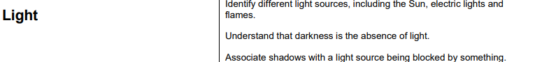

**Year 2**

**Year 3**

**Year 4**

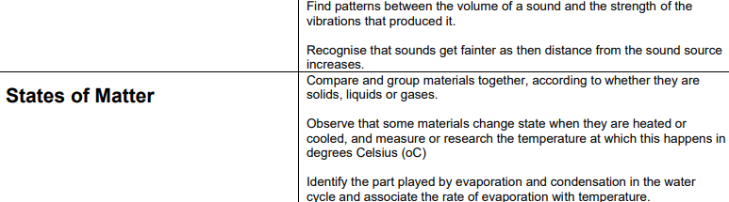

**Year 5**

**Year 6**

