Spellings – Mrs Siddiqui’s group
17.09.21
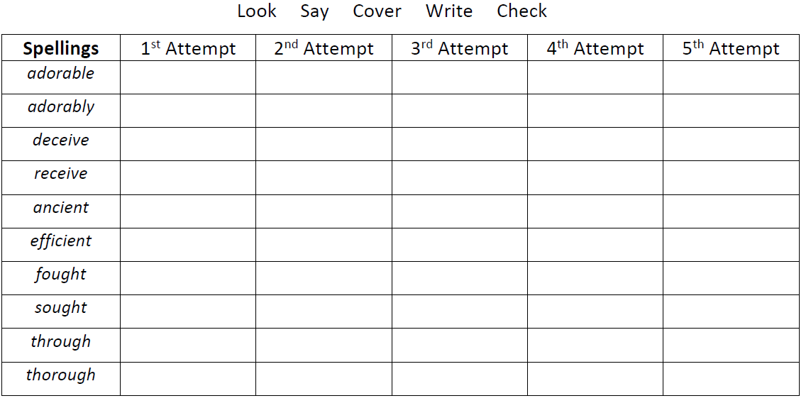

Spellings- Mrs Bird’s group
Spellings
could
would
should
accident
remember
consider
better
mother
brother
sister

