Spellings
Mrs Siddiqui’s group
24.09.21
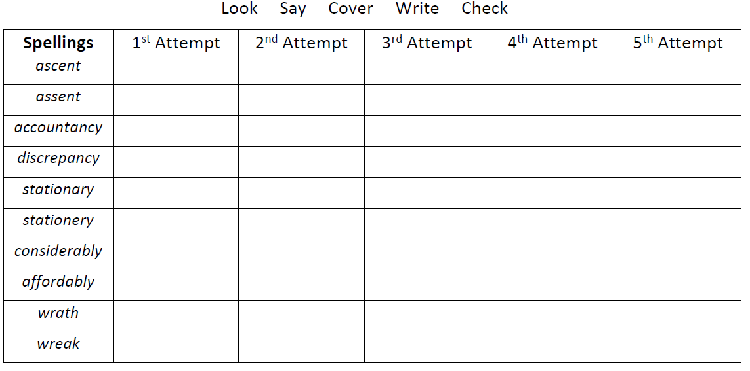

Spellings- Mrs Bird’s group
Spellings
imitate
separate
ventilate
investigate
illustrate
estimate
demonstrate
exaggerate
considerate
hesitate
Mrs Jones’ group
wait | say
rain | play
train | stay
afraid | day
paid | joy
soil | enjoy
coin | toy
oil | boy
point | annoy
join

