Squirrels Homework – 17.09.2021
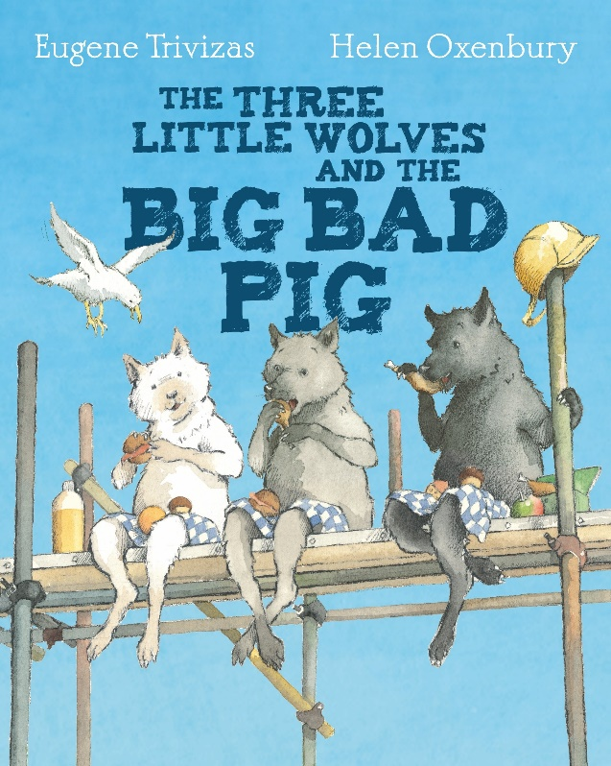

English:
This term, we have learning about traditional tales. The book we have been studying is ‘The three little wolves and the big bad pig.’
Activity: Have a go at retelling the story to your parents. The link below is a video of the story just in case you need to remind yourselves.
https://www.youtube.com/watch?v=qPW9VUm299I
Think about:
- What characters are there?
- How did the big bad pig destroy the houses?
- What happened in the end?

Maths:
Please answer the questions below in your homework books.

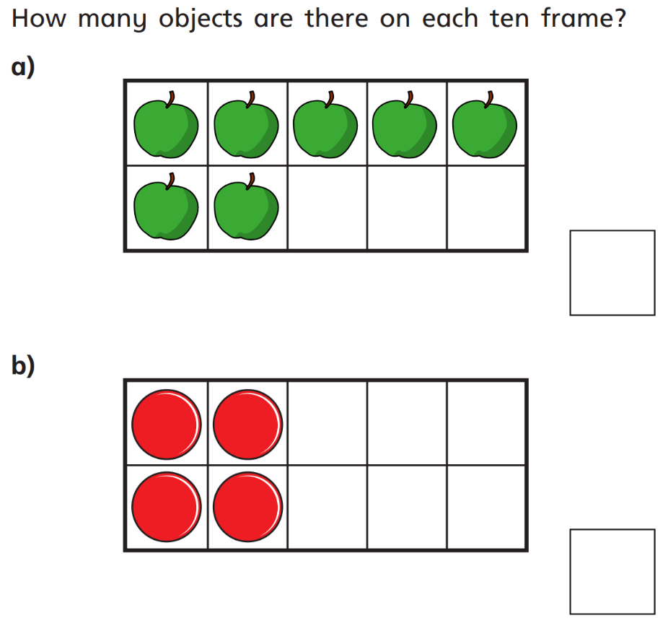
1.

2. Can you count forwards and write your numbers to 10?

3. Can you count backwards and write your numbers from 10 down to 1?

4. Draw the ten frames below in your books and find one more than each of these numbers.
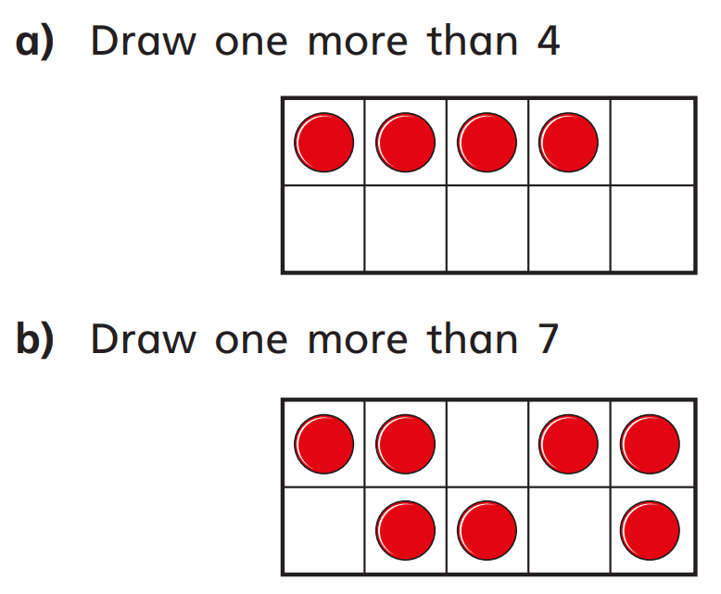

Challenge: Object Hunt
Think of a number between 1 and 10 and see if you can find that number of objects around your house.

