Squirrels Homework – 24.09.2021
Maths
Please answer the questions below in your books:
1. Use the number-line to help you answer the questions:
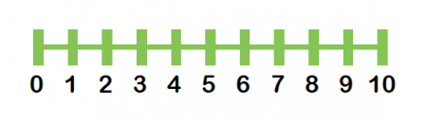

- One less than 6
- One less than 9
- One less than 1

2. Can each hand get a glove?
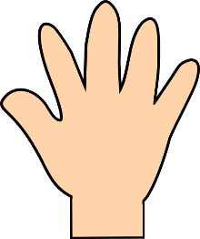

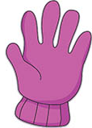

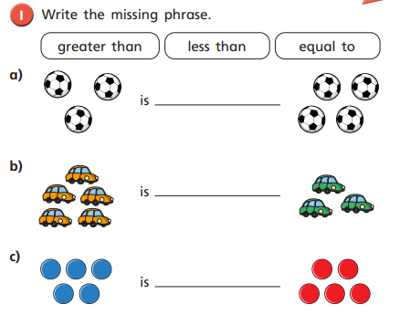
3. Figure out the numbers of each group of objects and use the correct phrase.

