17.09.21 Foxes Homework

MATHS

Warm up by finding a pair of dice and a timer. Set the timer for 3 minutes, roll the dice and multiply the number on the dice by 3 or 6, depending on which table you’re working on. Try this a few times over the week and watch how much better you get!

Please choose either A, B OR C to complete

A

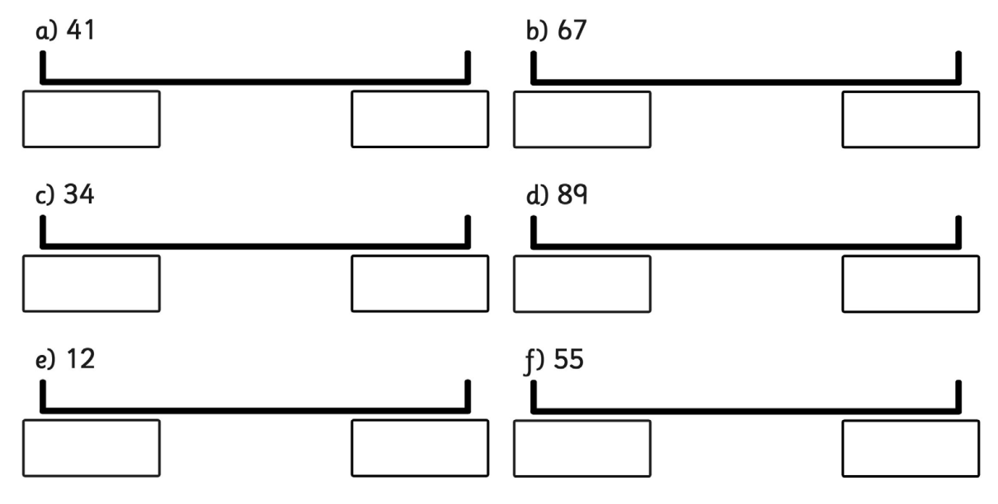

B

Round to the nearest 10

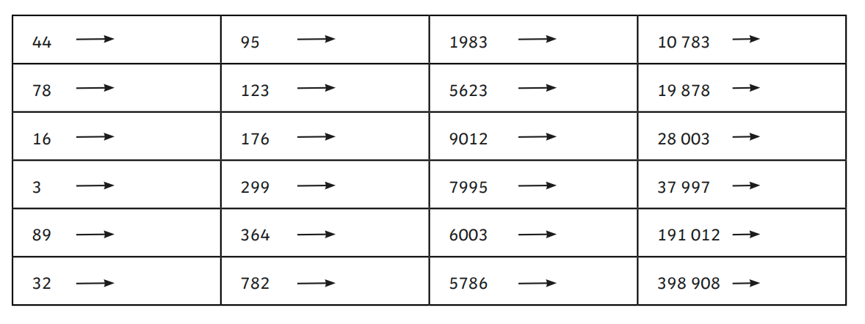

C

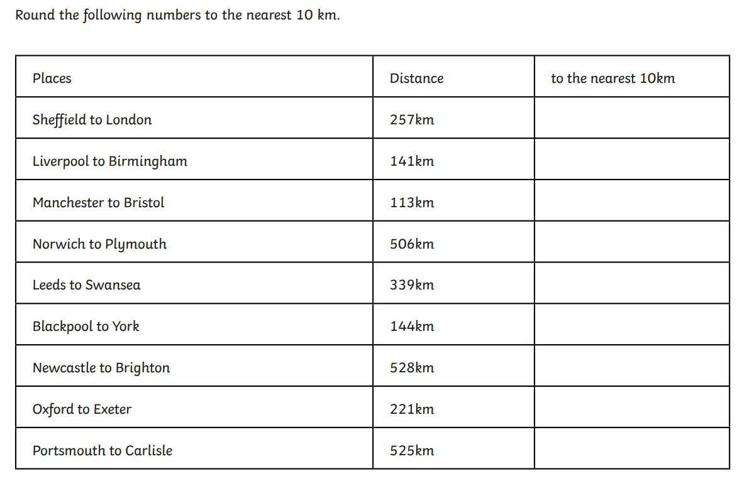

Challenge

A swimming pool gets about 120 swimmers between Monday and Friday and about 350 swimmers over the weekend. To the nearest 100, how many swimmers does the pool get over the whole week?

