Friday 25th September 2021 – Maths Homework.

Spend 3 minutes playing the dice times tables game. Throw a pair of dice, add the numbers together then multiply it by your chosen table. How many answers did you manage to get?

Then try either set A, B or C. There is a challenge question at the bottom for those adventurous enough to try.

A

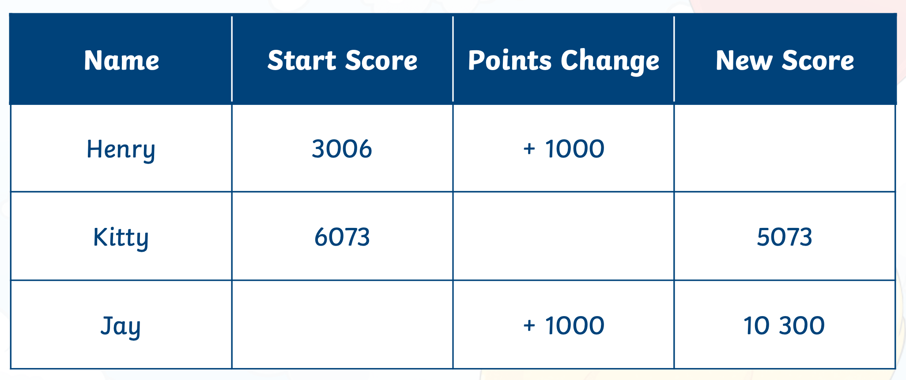

B

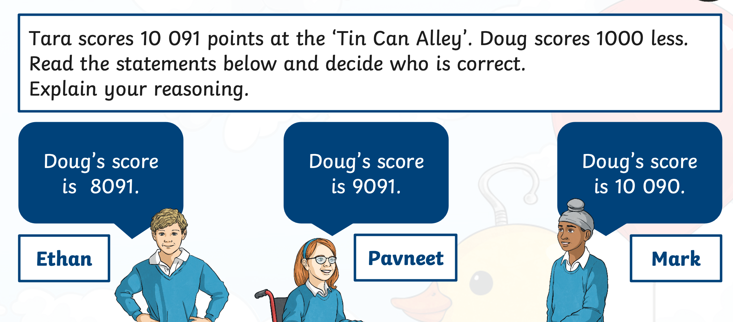

C

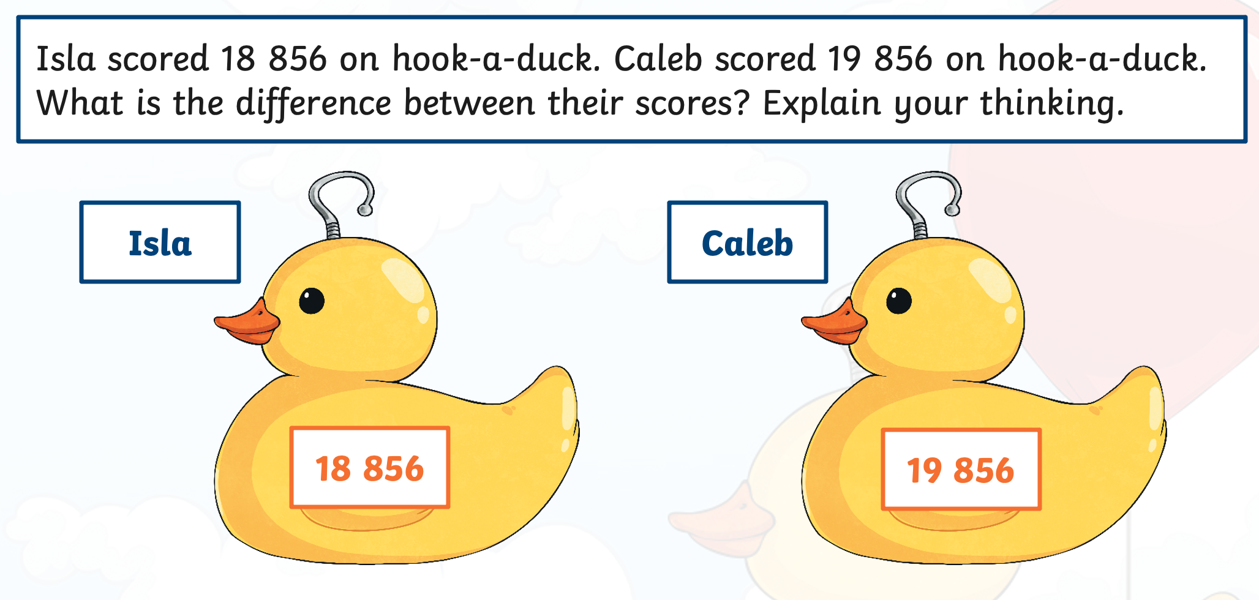

Challenge

