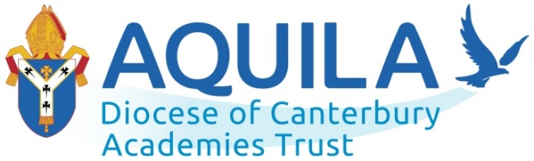
‘…those who hope in the Lord will renew their strength.
They will soar on wings like eagles; they will run and not grow weary,
they will walk and not be faint.’ Isaiah 40:31

connect | nurture | aspire | learn | excel | hope

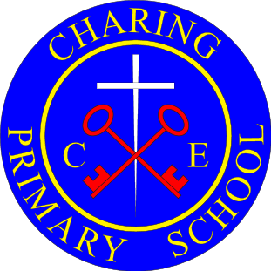

Charing Church of England Primary School
Science
Policy

Document Information | Date/source of Policy | Responsibility
Date of review | September 2021 | Science Leader / SLT
Date of new review | September 2023 | Science Leader / SLT

“Our school is an inclusive family, proud of our faith in God and friendship with the community. We develop respect, aspiration, curiosity, tolerance and determination. We are a creative, compassionate and confident team”

Confidence Determination Faith Friendship Respect

Charing Church of England Primary School

Science Policy 2021

But God made the earth by his power; he founded the world by his wisdom and stretched out the heavens by his understanding (Jeremiah 10:12)

- Statement

Charing Church of England Primary School understands the need for all pupils to develop their Scientific ability as an essential component of all subjects and as a subject in its own right. A good understanding of scientific knowledge and conceptual understanding helps to support pupils work across the curriculum.
- Aims and objectives
At Charing we believe that Science is a body of knowledge built up through experimental testing of ideas. Science is also a practical way of finding reliable answers to questions we may ask about the world around us. Science in our school is about developing children’s ideas and ways of working that enable them to make sense of the world in which they live through investigation, as well as using and applying process skills. We believe that a broad and balanced science education is the entitlement of all children, regardless of ethnic origin, gender, class, aptitude or disability.
Our aims in teaching science include the following:
• Preparing our children for life in an increasingly scientific and technological world today and in the future.
• Helping our children acquire a growing understanding of the nature, processes and methods of scientific ideas.
• Helping develop and extend our children’s scientific concept of their world.
• Building on our children’s natural curiosity and developing a scientific approach to problems.
• Encouraging open-mindedness, self-assessment, perseverance and developing the skills of investigation – including: observing, measuring, predicting, hypothesising, experimenting, communicating, interpreting, explaining and evaluating.
• Developing the use of scientific language, recording and techniques.

• Making links between science and other subjects.

- Statutory Requirements
Statutory requirements for the teaching and learning of Science are laid out in, The National Curriculum in England Framework Document for Teaching, September 2014 and the Statutory framework for the Early Years Foundation Stage, September 2014.

- Teaching & learning
Planning for science is a process in which all teachers are involved to ensure that the school gives full coverage of, ‘The National Curriculum programmes of study for Science 2014’ and, ‘Understanding of the World’ in the Early Years Foundation Stage. Science teaching at Charing involves adapting and extending the curriculum to match all pupils’ needs. Where possible, Science will be linked to class topics. Science will also be taught as discrete units and lessons where needed to ensure coverage. This ensures progression between year groups and guarantees topics are covered. Teachers plan to suit their children’s interests, their own teaching style, the use of any support staff and the resources available.
Foundation Stage (reception pupils): Pupils explore science topics through making predictions, using their senses and investigating materials and their properties. Science is taught through the strand of, ‘Understanding the World’. Science teaching and learning is also linked to the other strands of The EYFS framework for learning, 2014. Teachers and teaching assistants support pupils to develop a solid understanding of things occurring around them in their day-to-day lives. Children are encouraged to be creative and inquisitive as they participate in activities. Pupils are encouraged to use their natural inquisitiveness, while taking part in exploratory play in specific scientific areas as well as areas that link across the EYFS framework.
Key Stage One: During Key Stage one, pupils observe, explore and ask questions about living things, materials and the world around them. They begin to work together to collect evidence to help them answer questions, find patterns, classify and group objects, research using a variety of sources and carry out fair testing. Pupils use reference materials to find out more about scientific ideas. They share their ideas and communicate them using scientific language, drawings, charts and tables. Science lessons in Key Stage one are either taught discretely or where possible connected to other curriculum areas. Pupils often use the outdoor areas in their science learning.
Key Stage Two: Children are encouraged to extend the scientific questions that they ask and answer about the world around them. Pupils carry out a range of scientific enquiries including: observations over time, pattern seeking, classifying, grouping and researching using other sources (including computing resources). Children in Key Stage Two learn to plan science investigations by changing variables to create a fair test. Pupils in Key Stage two extend their scientific learning using the outdoor areas.

- Monitoring and review

The monitoring of the standards of children’s work and of the quality of teaching in Science is the responsibility of SLT and the Science subject leader. The work of the subject leader also involves supporting colleagues in the teaching of Science, being informed about current developments in the subject, and providing a strategic lead and direction for the subject in the school.

6. Assessment and Target Setting
Children’s progress is continually monitored throughout their time at Charing and is used to inform teaching and learning. By the end of each key stage children are expected to know, apply and understand the matters, skills and processes specified in the relevant programme of study as set out in the National Curriculum.
Children receive effective feedback through teacher assessment in line with schools marking policy. Assessment for learning is continuous throughout the planning, teaching and learning cycle using:
- Observations of the children at work, individually, in pairs, in a group and in class
- Questioning, talking and listening to children.
- Considering their ‘Working Scientific Skills’ and how they can apply those skills within the topic.

7. Equal Opportunities
Charing Primary School has universal ambitions for every child, whatever their background or circumstances. In order to engage all children: cultural diversity, home languages, gender and religious beliefs are all celebrated. In our school we aim to meet the need of all our children by providing a variety of approaches to scaffold learning, enabling all to achieve. Teachers use the school’s inclusion policy to ensure that a range of strategies are used which includes and motivates all learners, ensuring that optimum progress is made throughout the lesson

8.Role of Subject Leader: The Subject Leader should be responsible for improving the standards of teaching and learning in Science through:
• Monitoring and evaluating pupil progress;
• Provision of Science;
• The quality of the learning environment;
• Taking the lead in policy development;
• Auditing and supporting colleagues in their CPD;
• Organising resources;
•Keeping up to dates with changes in the subject
This policy will be reviewed every two years or in the light of changes to legal requirements.

