English 8.10.21
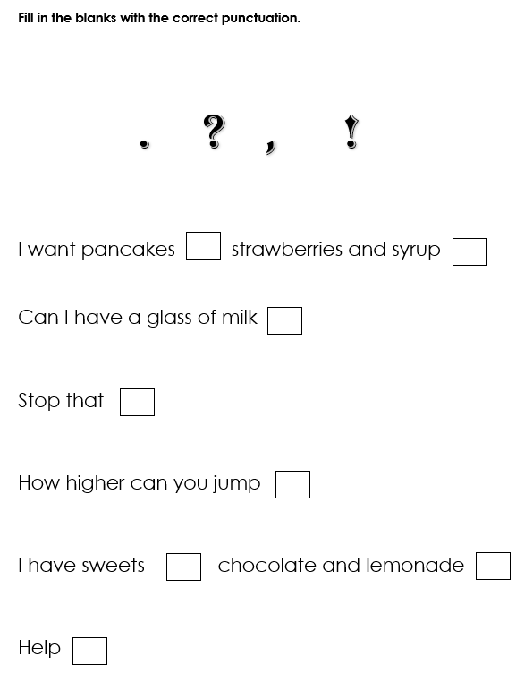

Try to write some sentences of your own using the following punctuation . , ?!

