Grammar
(there is a choice of tasks, use the one that’s right for you)
Task A
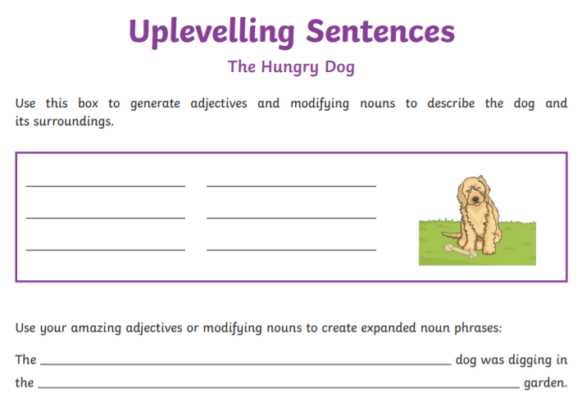
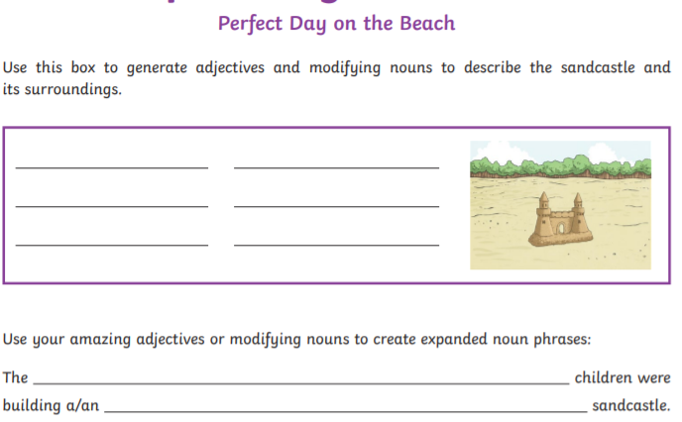
Task B
Use these steps to improve the sentences below:

1. Begin your sentence with a fronted adverbial.
2. Use modifying nouns and adjectives to create expanded noun phrases.
3. Add a subordinating conjunction to give extra detail.
