Maths homework 15.1.21
Try to do as many of these questions as you can. Remember to use the number line to show your jumps.
Eg 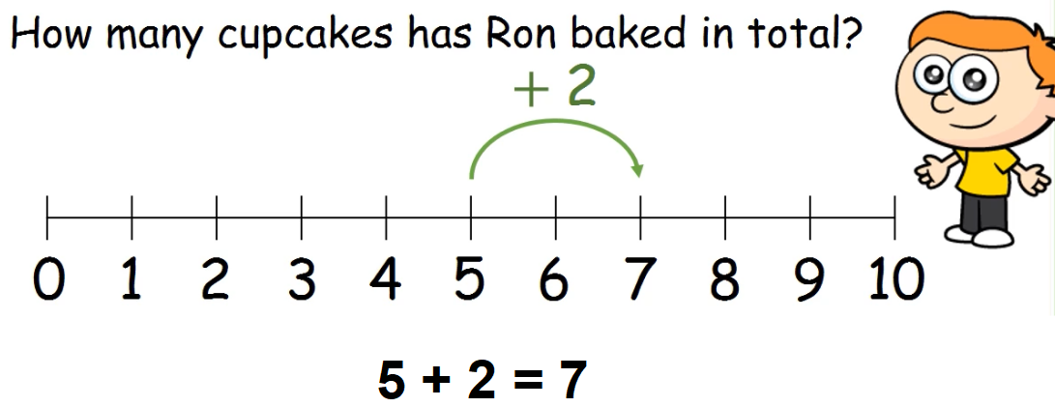

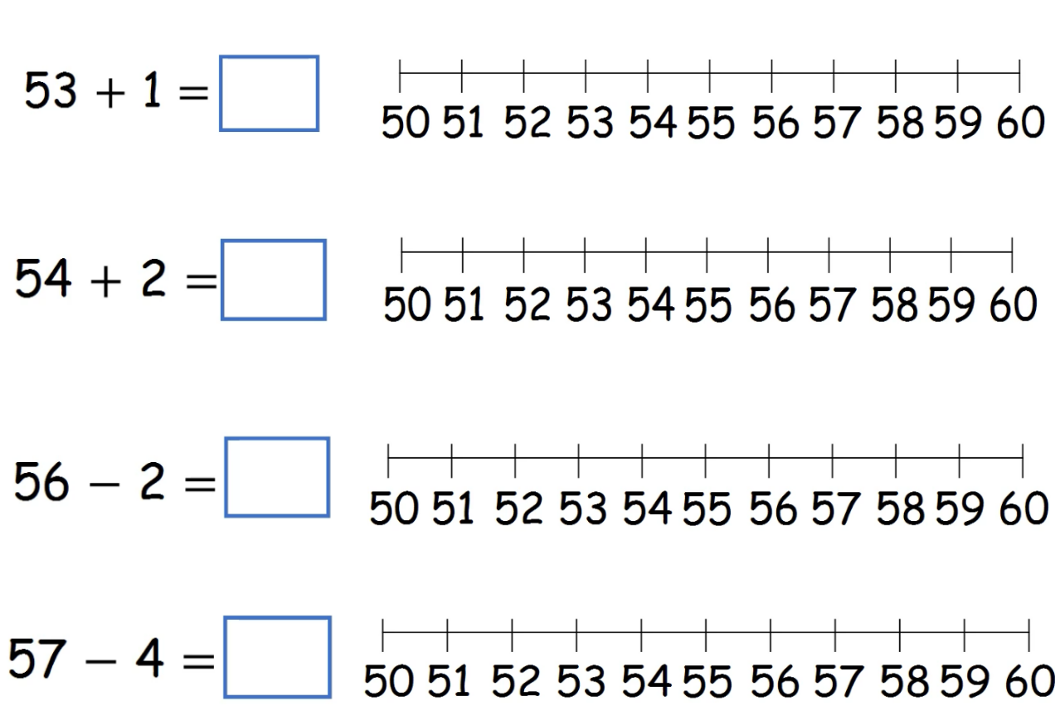

Challenge
