Spellings
Mrs Siddiqui’s group
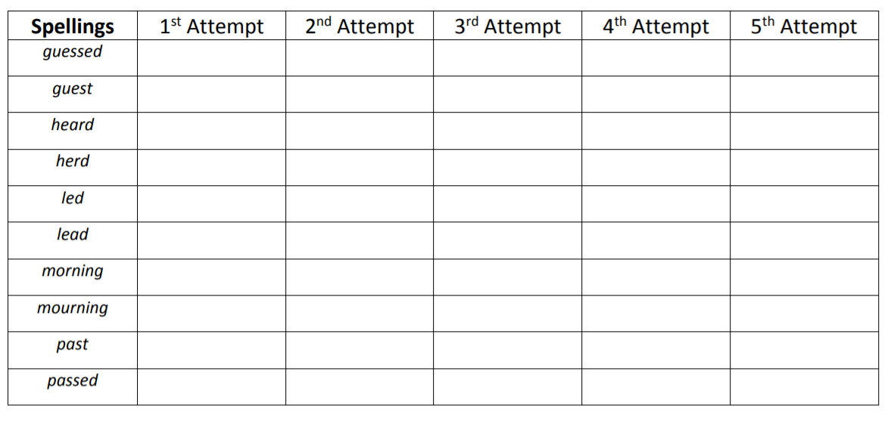
Spellings- Mrs Bird’s group
Spellings
famous
curious
tremendous
furious
enormous
dangerous
jealous
various
nervous
anxious

Ms Jones and Ms Dowsett’s group
Spellings
read
each
reach
meat
dream
tea
sea
field
chief
thief

