Spellings
Mrs Siddiqui’s group
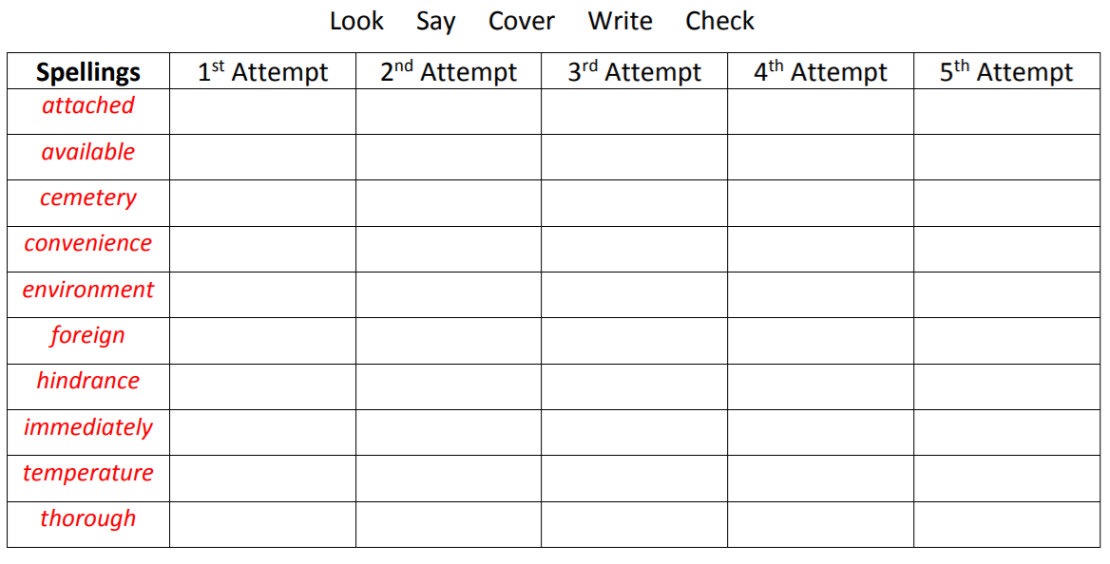
Spellings- Mrs Bird’s group
Children in Mrs Bird’s group will be spending time learning the spellings (below) in class, next week.
Spellings
appreciate
accommodate
interrupt
appear
disappear
tomorrow
followed
suggest
correspond
swimming

Ms Jones and Ms Dowsett’s group
Spellings
read | today
each | were
reach | was
meat | said
dream | your
tea | they
sea | there
field | where
chief | come
thief | some

