Spellings
Mrs Siddiqui’s group
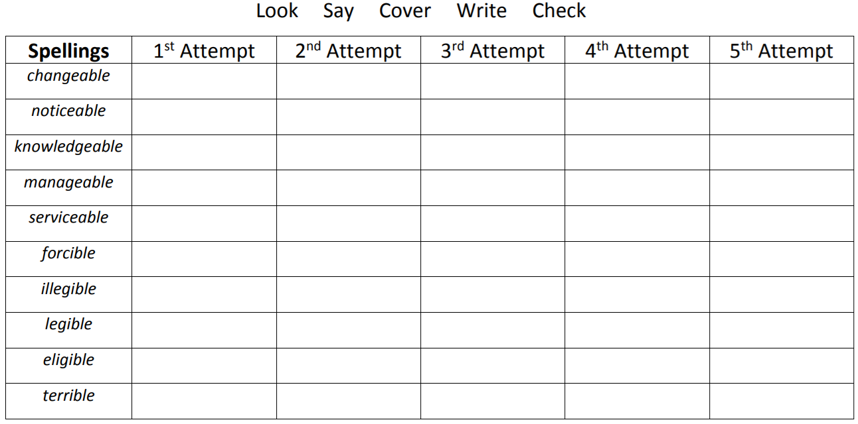
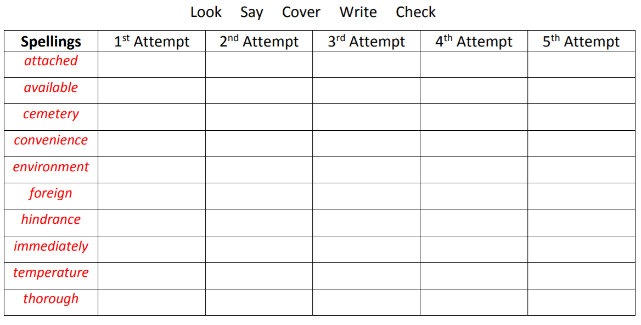

Spellings- Mrs Bird’s group
Children in Mrs Bird’s group will be spending time learning the spellings (below) in class, next week.
Spellings
should
accident
consider
separate
hesitate
exaggerate
dangerous
jealous
anxious
appreciate
disappear
ridiculous
explanation
preparation

Ms Jones and Ms Dowsett’s group
Spellings
flute
use
tune
June
tube
rule
rude
cube

