Squirrels Homework – 01/10/2021
English

We are starting a new book!
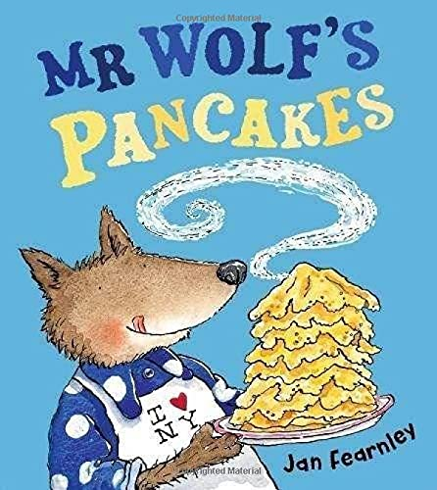

Please watch this link and talk to your adult about the questions below - https://www.youtube.com/watch?v=CXQDiqHp-xM
Challenge – Have a go at answering some of the questions in your homework books.

1. Who are the characters in the story?
2. What did each of the neighbours say to Mr Wolf?
3. Why did his neighbours go to his house?
4. What happened at the end of the story?

