Squirrels Homework – 15.10.2021
English
It is our final week of ‘Mr Wolfs pancakes!’
It’s time to make some pancakes. Find yourself a recipe and have some fun making pancakes with your adults.
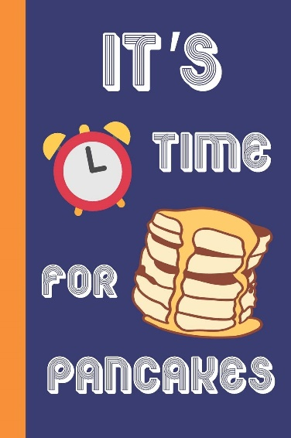
Think about:
What are you going to have on top?
How long does it take?
What ingredients do you need?

Please stick a picture in your homework books of your fantastic pancakes! It would be great to see your fabulous creations.

Challenge:
Have a look at the picture below. Can you write some sentences about what Mr Wolf needs for his pancake recipe?
