Squirrels Homework – 01.10.2021
Maths
1. Write in the missing phrase to make the statements correct:
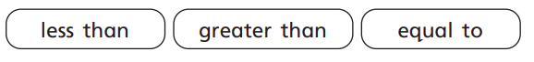
- 5 is __________________________________ 9

- 8 is __________________________________ 2

- Six is _________________________________ 6

2. Please use the gator signs below to compare the numbers:

- 7 10

- 4 4

- 9 6

3. Can count these groups of objects and write them from smallest to greatest?
v

4. Can you write your numbers from smallest to greatest?

5. Can you write your numbers from greatest to smallest?

