Squirrels Homework – 08.10.2021
Maths
1. The shapes below are having a race. Please write 1st, 2nd, 3rd, 4th, 5th in your homework books and draw which shape has come in each position:

2. Please write the answers to the questions in your books using the pictures to help you:
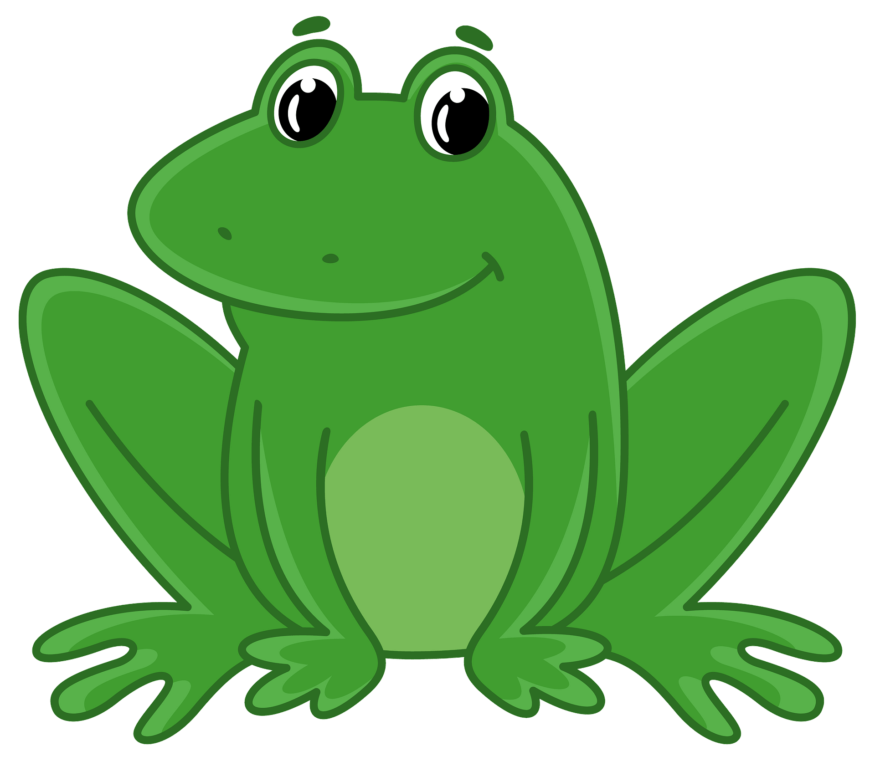
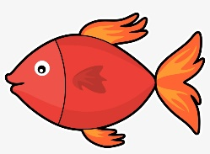
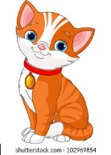

- Which animal is first?
- Which animal is third?
- Which animal is last?

3. Have a go at writing your numbers to 10 in your homework books using the number line below to help you. Then use the number line you have drawn to complete the questions:

- Can you circle one more than 6
- Can you circle one less than 10
- Can you circle the smallest number?

4. Can you fill in the missing numbers?
a) 1 2 ___ ___ 5 6 7 ____
b) 10 9 8 ____ _____ _____ 4 3 2 _____

