Squirrels Homework – 15.10.2021
Maths
1. Please use coloured pencils to complete the questions below.
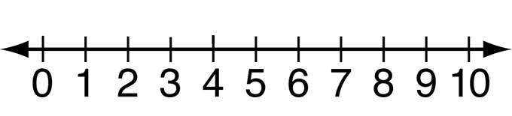
a) Can you circle 7 on the number line?

b) Can you circle one more than 4 on the number line?

c) Can you circle one less than 9 on the number line?

d) Use the example below to help you answer the question below.
Example: How many jumps from 2 to 6?
4
3
2
1

Now it’s your turn:
How many jumps from 5 to 9?

2. Please look at the question below about ‘Part-Part-Whole’ models.
Below there are some shapes.

- Please put the shapes into the 2 groups below.

- Can you put the shapes into two groups in a different way?

