Foxes Homework – Writing 1ST October 2021

Read the passage below and then choose which questions to answer. EITHER A OR B.

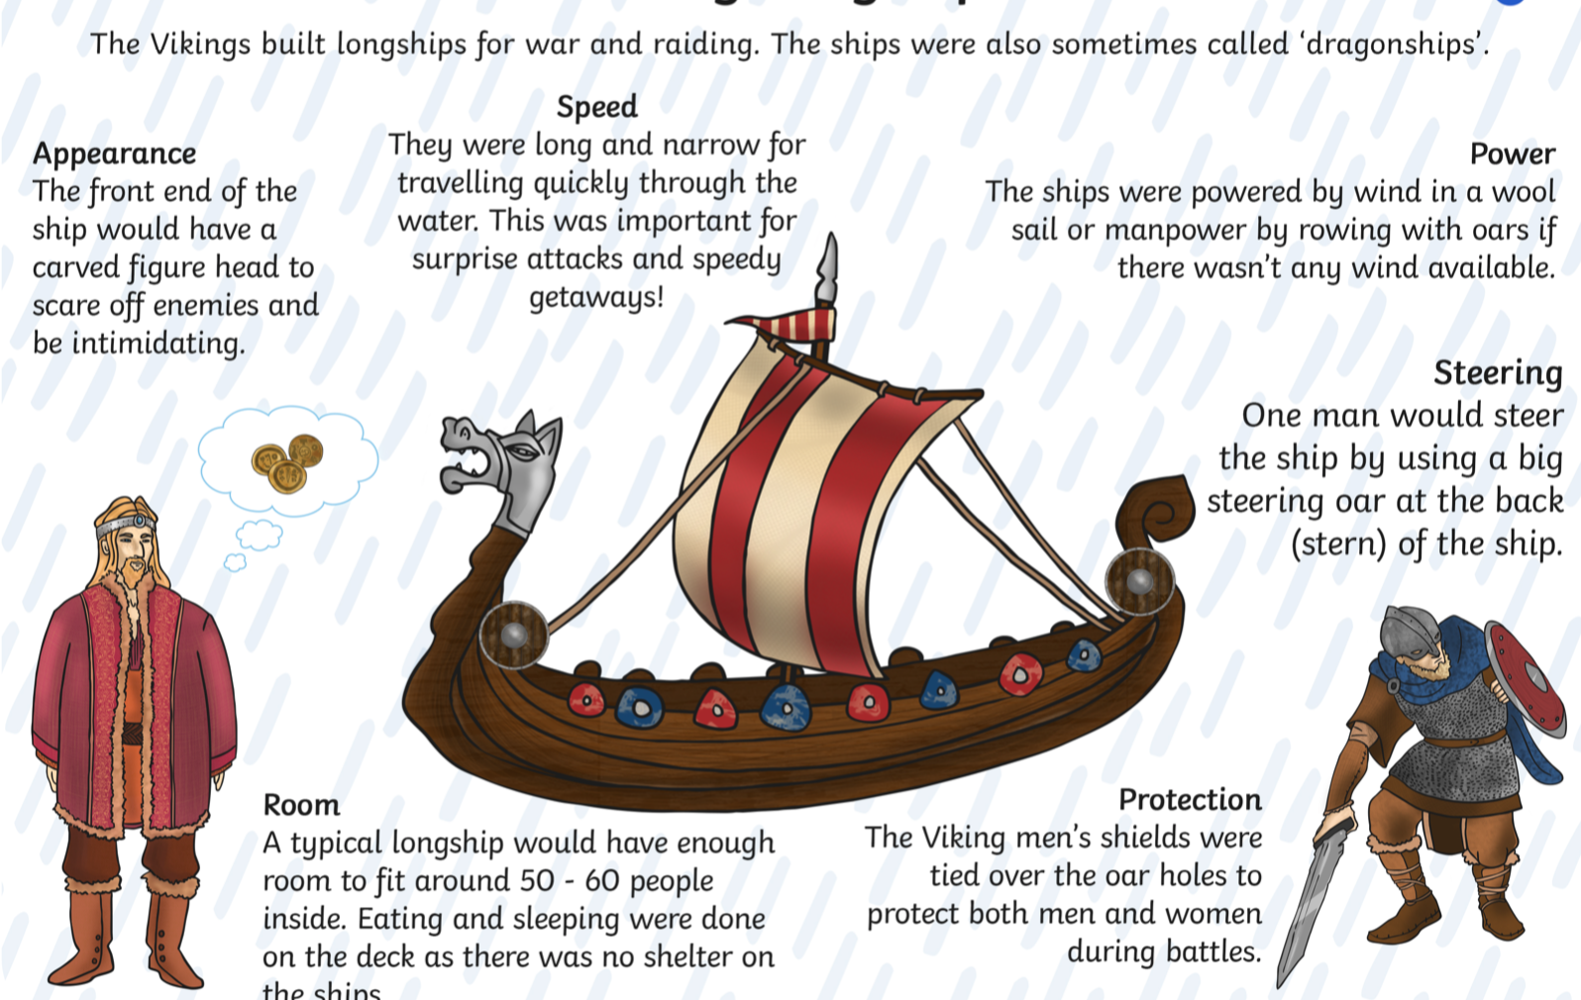

A
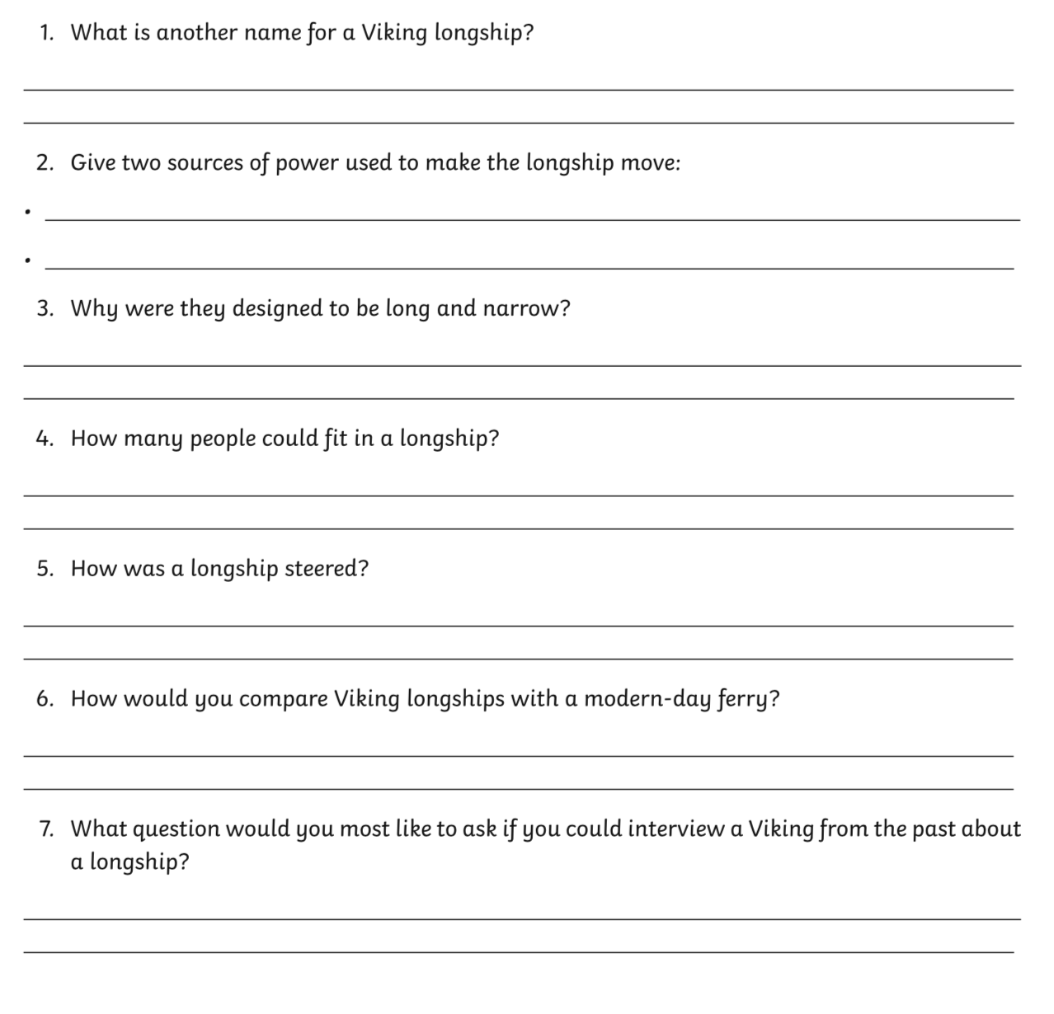

B

