Foxes Homework – 8.10.21 – Maths

Play the times table game with dice for 5 minutes. To recap; find 2 dice and choose a table, roll the dice, add the numbers together then multiply this by your chosen table. I bet you’re getting loads more done now!

Now complete either A OR B OR C

A

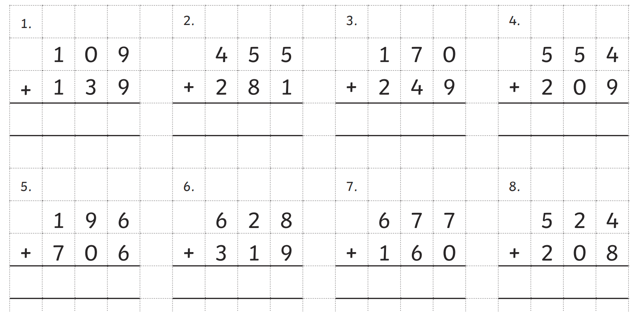

B

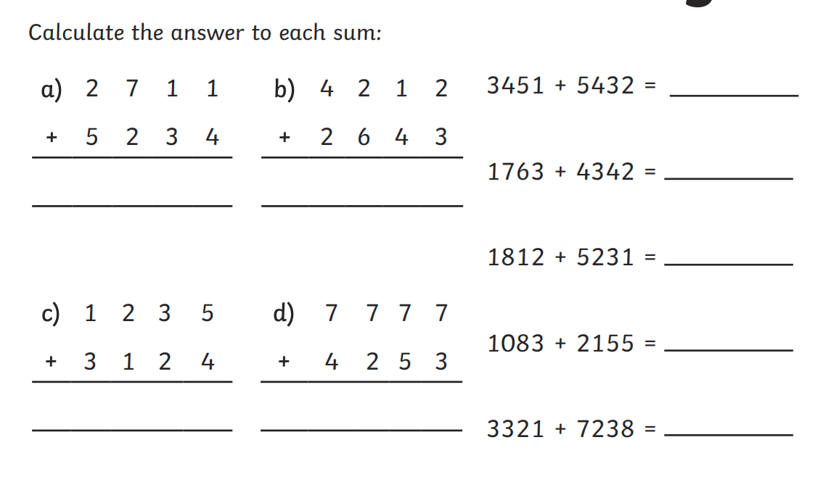

C

