15.10.21
Foxes English Homework

Please read the poem below then answer one of the sets of questions below. Set B is more of a challenge.

Remember that ‘stanza’ means lines that are grouped together. In this poem every four lines makes a stanza.

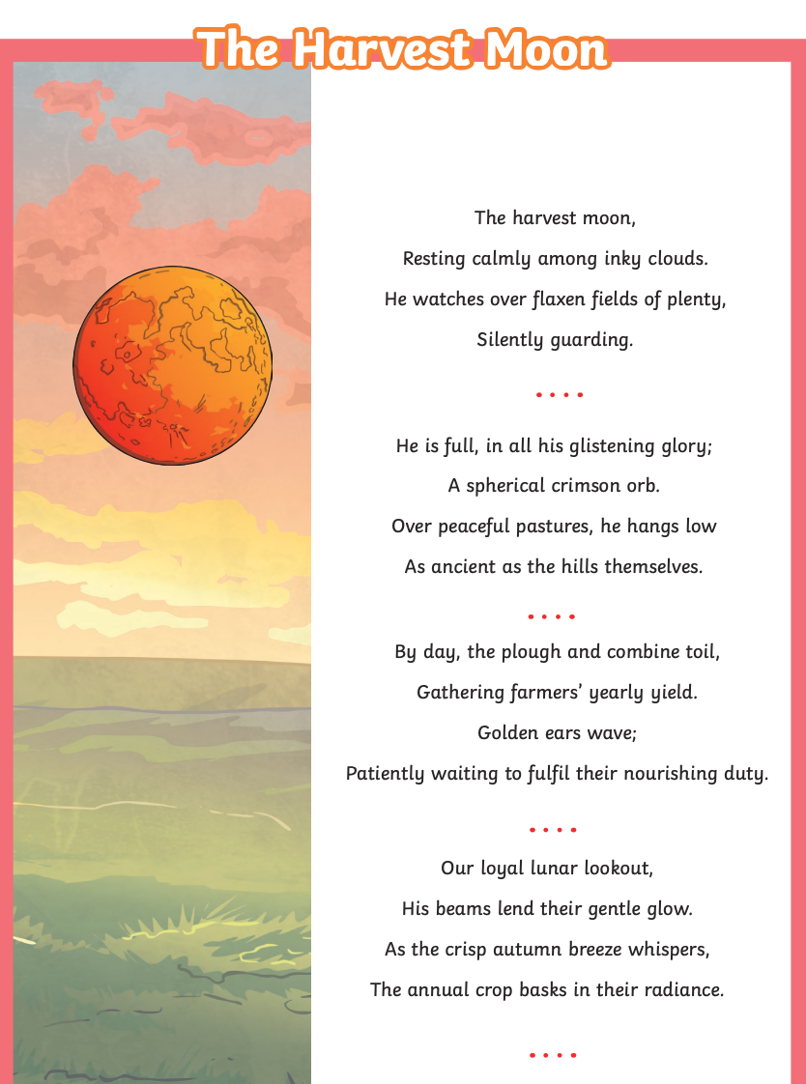

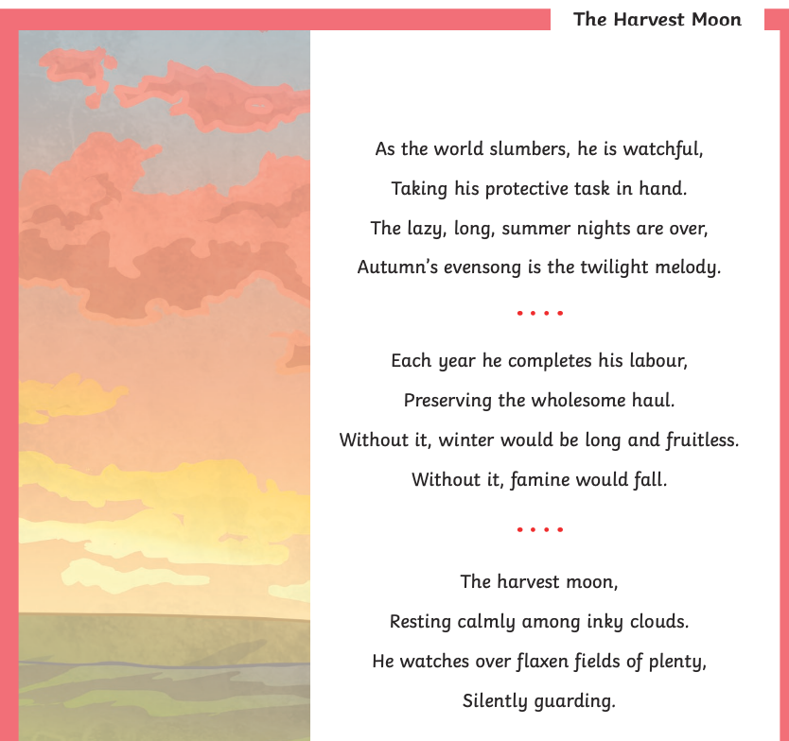

QUESTIONS – A

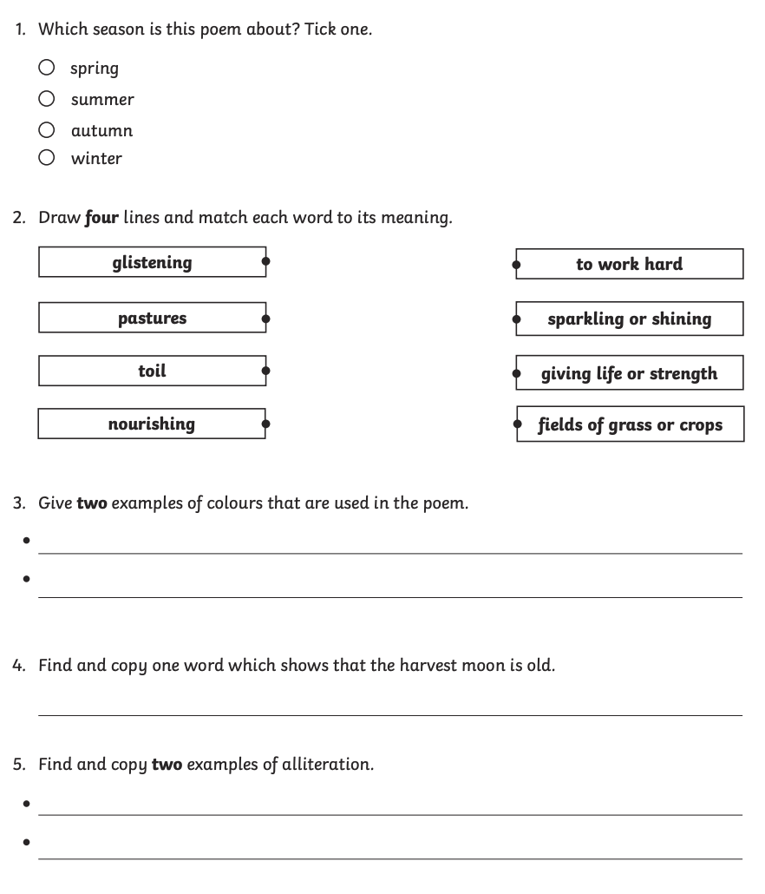

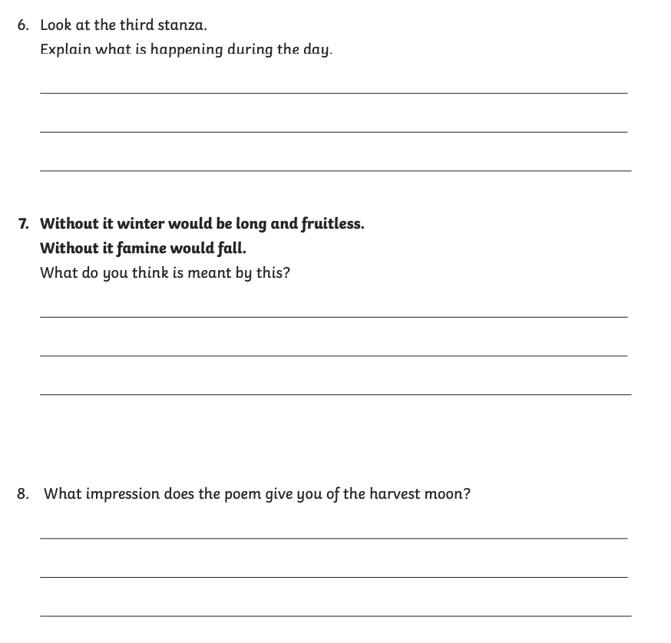

QUESTIONS – SET B

