Maths 26.11.21

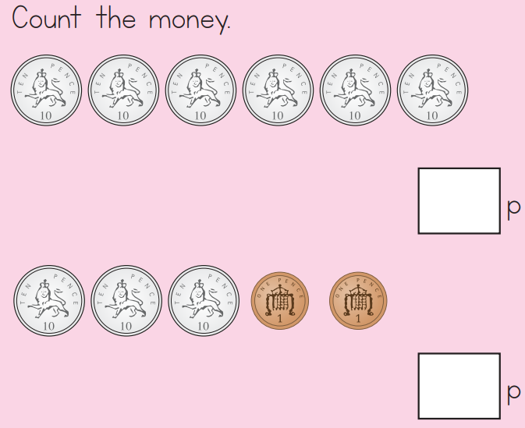

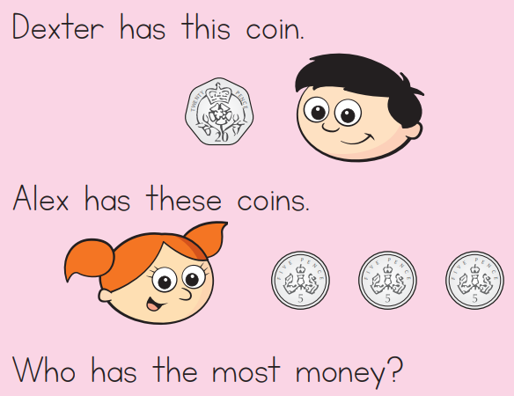

Challenge

Can you find 3 different ways of making £1

Draw the coins.