Spellings
Mrs Siddiqui’s group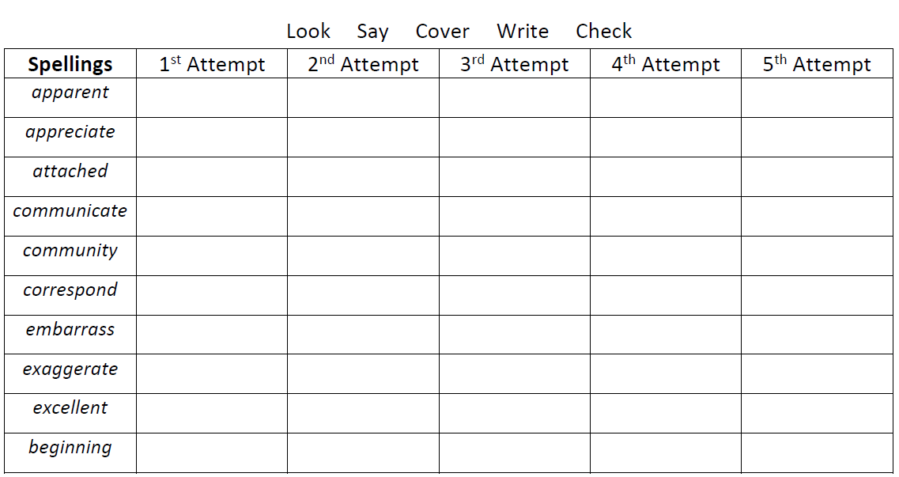

Spellings- Mrs Bird’s group

Spellings
enough
through
bought
brought
cough
tough
rough
thorough
although
ought

Ms Jones and Ms Dowsett’s group
Spellings
person | house
bread | came
better | but
letter | sketch
anger | thank
buzz
pack
back
fizz
says

