Squirrels Homework – 19.11.2021
English/History
We have been learning about the Great Fire of London in both English and History. Below I have written some sentences which have some parts missing. Please use the pictures below and write some different facts about the Great Fire.

1. The Great Fire of London started on the _____________________________________________________.
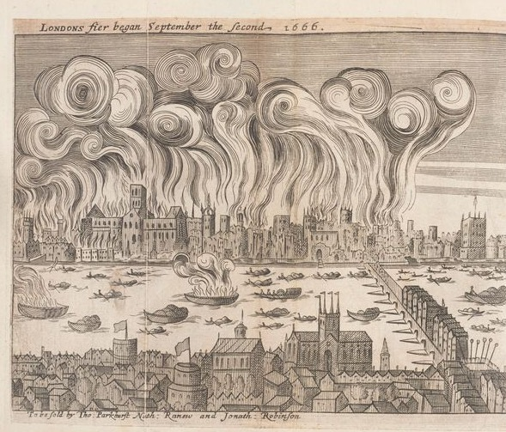

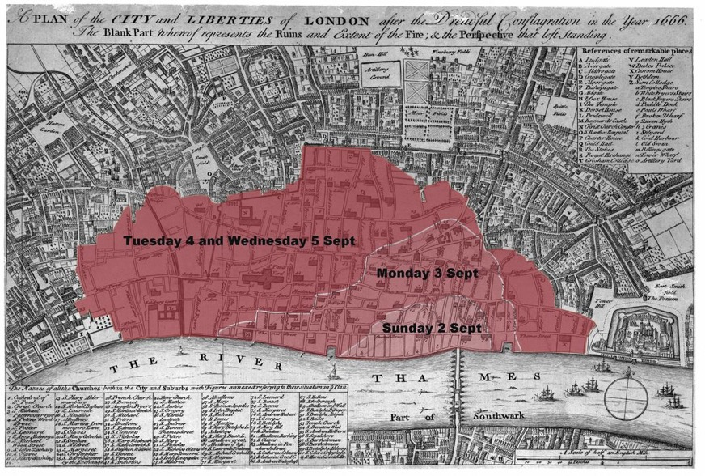
2. It lasted for _____________ days.

3. The fire started in ____________________.
Challenge: What shop did it start in?
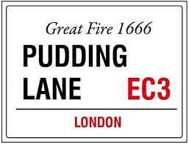

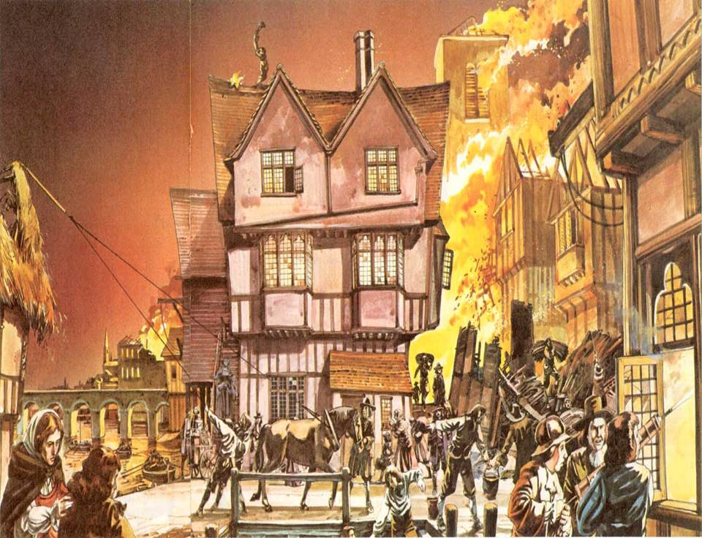
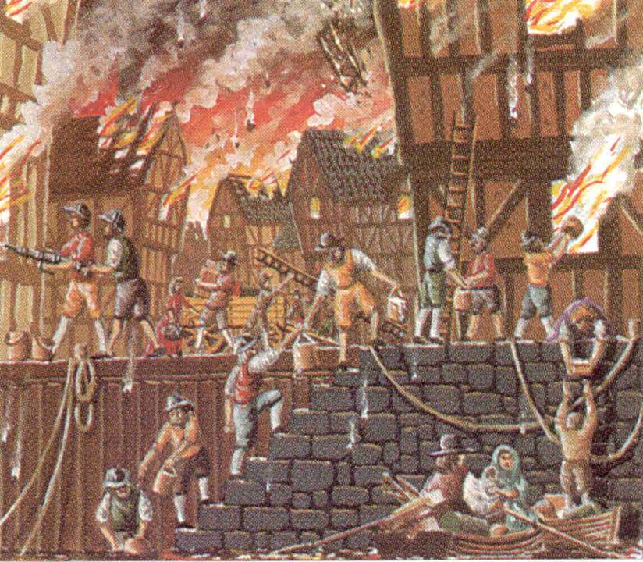
Challenge: Can you remember any other facts about the Great Fire? I have put a few pictures below to help you!
