Squirrels Homework – 26.11.2021
English/History
This week, we are working towards writing an information piece about the ‘Great Fire of London.’
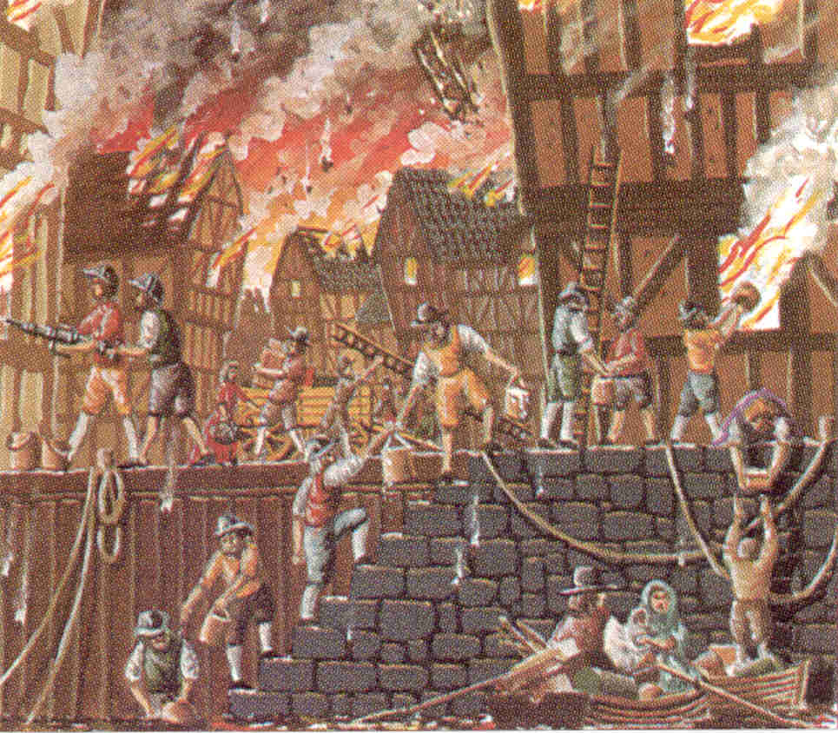
Please have a look at the picture and tell your adult 3 reasons why the fire spread so quickly. – I have put a word bank below and some arrows on the picture to help with your ideas.

Word Bank:
buckets | wood | narrow | wind | houses
ladder | thatch

