Squirrels Homework
English
This term we are learning about ‘The Great Fire of London.’
Watch our story for this term: ‘Toby and the Great Fire of London.’ - https://www.youtube.com/watch?v=ABCjhIA-dOs

Challenge Questions:
- What was Toby taking to Mr Pepys?
- Who are the two ‘real’ characters in this story?
- What was Mr Pepys hiding in the pit?

Phonics!
Have a look at the sounds below and check how you are doing!
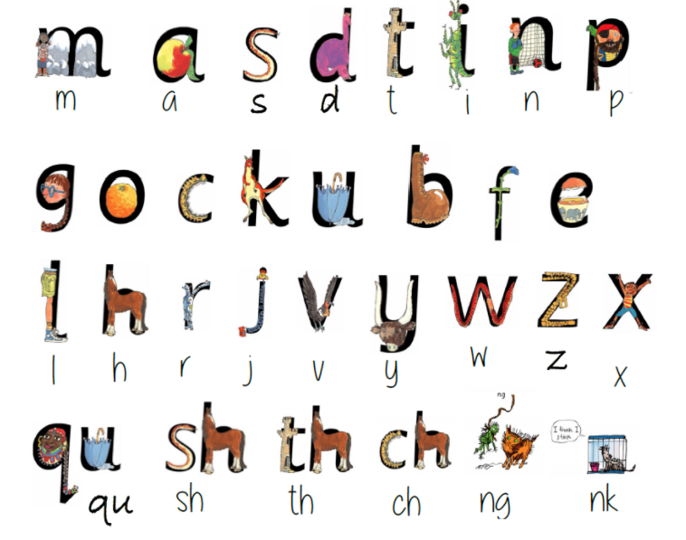

Can you write some words using these sounds?

