Squirrels Homework – 05.11.2021
Maths
This term we have been learning about addition. Please have a go at answering the questions below.
1. Please use the part-part-whole models below to write your number sentences. The first one has been done for you.
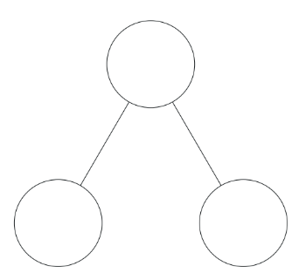
Example:
4 + 2 = 6
6
2 + 4 = 6
6 = 4 + 2
2
6 = 2 + 4
4

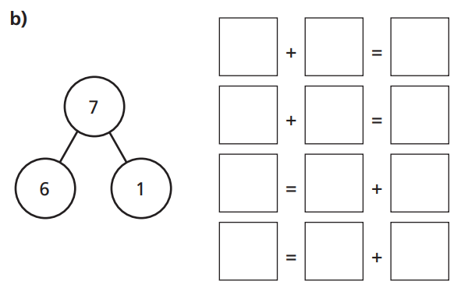

3
9

2. Can you write down your number bonds to ten?
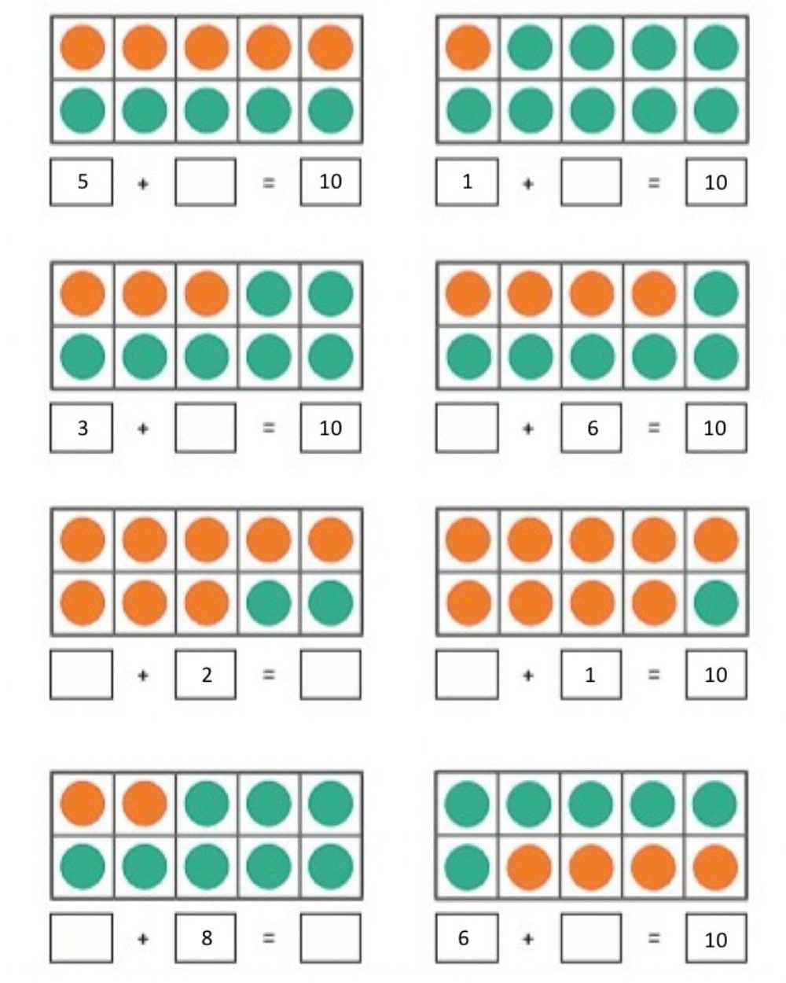
10

10

