Squirrels Homework – 12.11.2021
Maths
1. Please work out the answers to the number sentences below and use your ‘gator’ signs to make the statements correct:
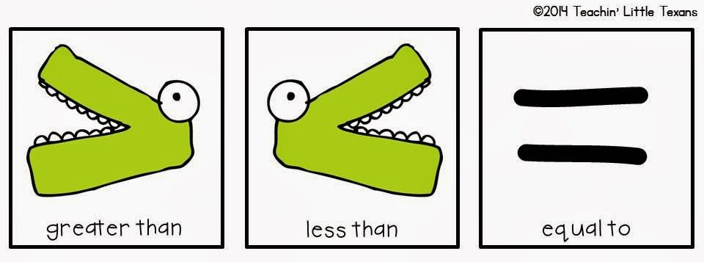

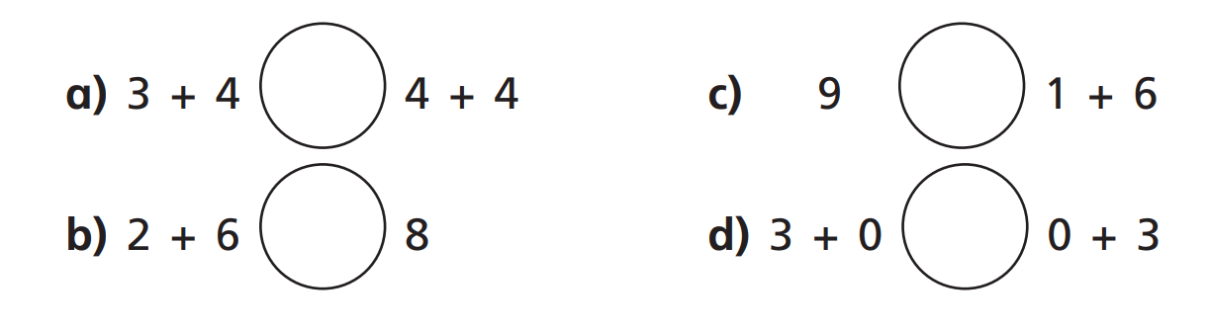
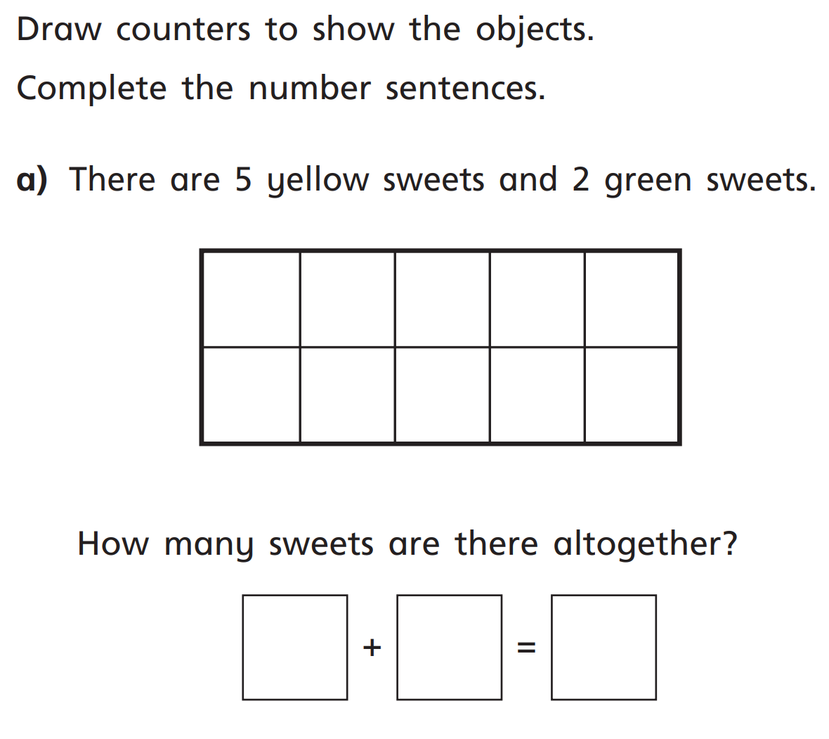
2.

3. Mo has 4 sweets.

Sam gives him 3 more.

How many sweets does Mo have altogether?

