Squirrels Homework – 19.11.2021
Maths
1. Can you write down the number sentences that make 6?
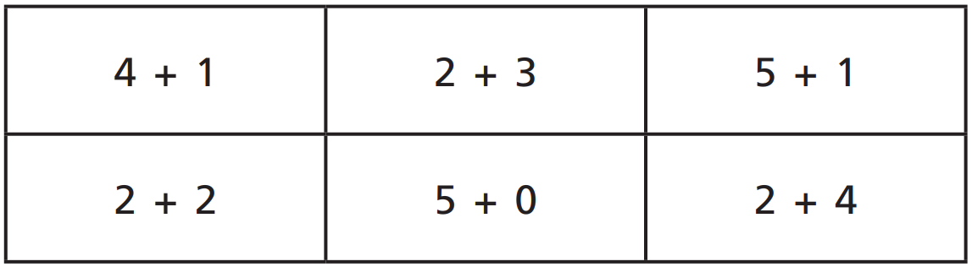
0 + 6
2 + 4
3 + 3

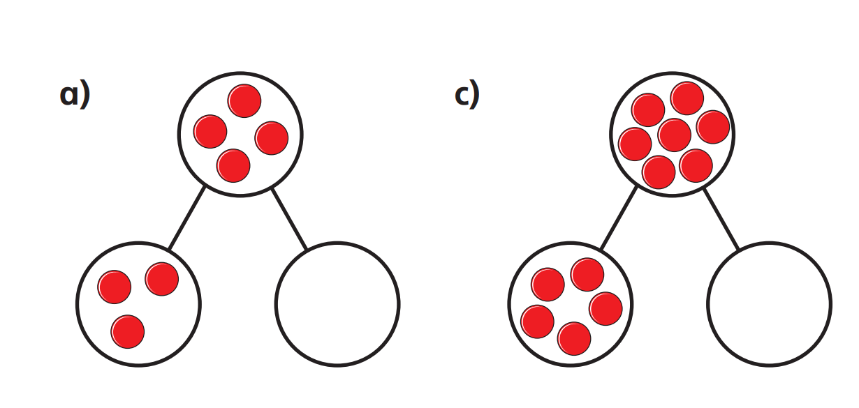
2. Draw the part-part-whole model below and work out the other part number.

3. Miss MacMillan has 7 sweets.

Mo eats 3 of them.
How many are left?

