Squirrels Homework – 26.11.2021
Maths

1. Please look at the sweets below. How many are stripy?
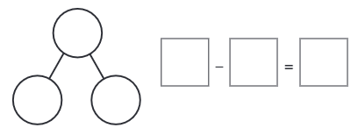
5
5

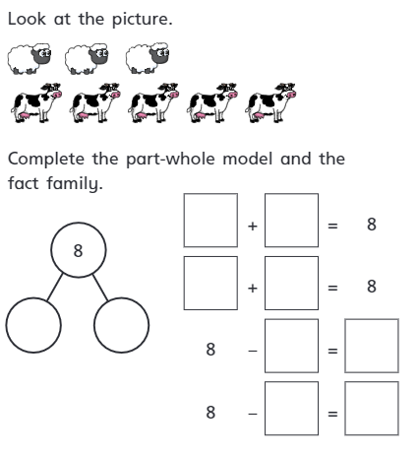
2.

3. Finding the difference:
Tom has 5 toy cars.
Ben has 2 toy cars.
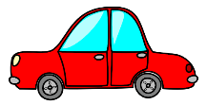

How many more toy cars does Tom have than Ben?

Challenge:
Can you fill in the number sentence below for question 3?
=
-

