Maths Homework – 5th November 2021
Please find a deck of playing cards and practise your 3 and 6 times tables by shuffling the cards and dealing yourself one then multiply that by your chosen table. Can you get through the entire deck of cards in under 2 minutes?
Then complete 1 section from the questions below. Section B is more of a challenge. Have a go at the challenge if you have time.
Section A
- Draw a line to match the description to the correct representation. What is the total?
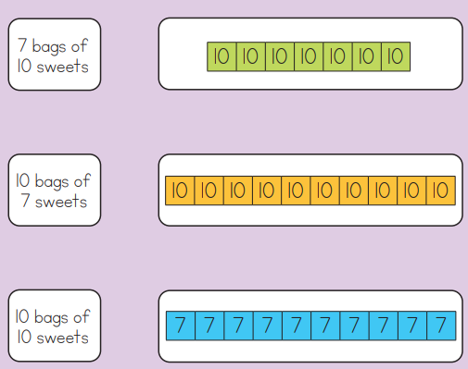

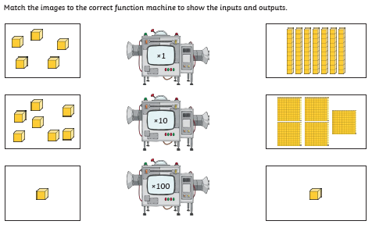

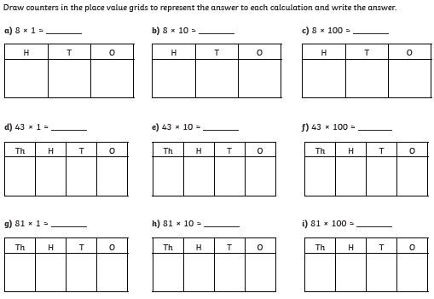

Section B
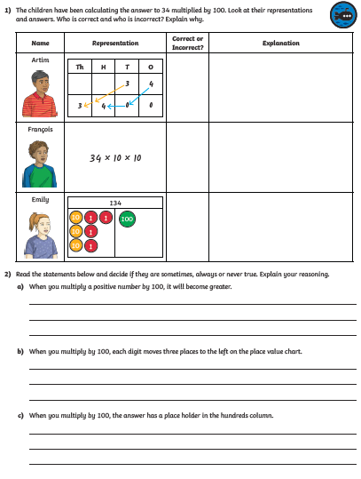

Challenge
