Homework – Writing – 26th November 2021
Look carefully at the picture below.
What can you see? How long ago was this? What are the glowing baubles? What is the man doing and what is he carrying?
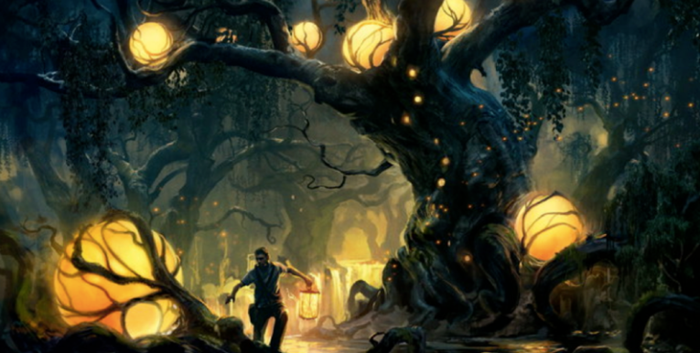

Now either write five amazing sentences to describe this picture or write a beautifully descriptive paragraph. Choose your vocabulary carefully and try to use some interesting similis. Remember to punctuate your work carefully.

