Maths Homework 26th November 2021
Common Factors.
Remember to practise your times tables. You can do this online by listening to videos or visit https://www.topmarks.co.uk/maths-games/hit-the-button and play for 10 minutes. Then complete ONE section about factors below.
A
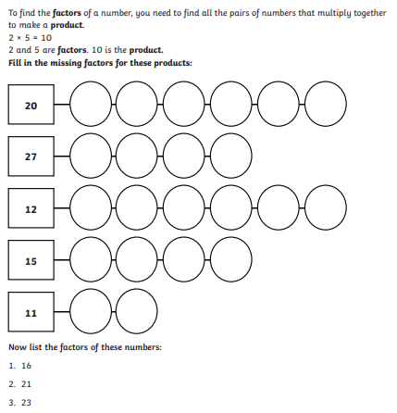

B
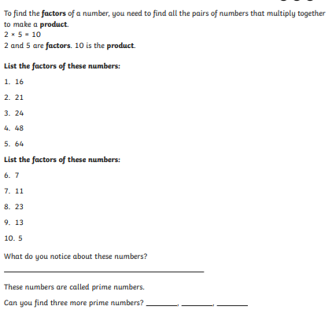

C
